The Official Publication of ALOA—An International Association of Security Professionals

January 2002

[www.aloa.org](http://www.aloa.org)

iCr-

PJ

. o

1 £ i o

o i i : pj

5 S

CO

“OCO

cr-

**jo<x**

r-o

E <C **XP**

*0:5

**jj** —1

rOP

P&Cu<C

poking  
Back  
o See  
rward:

j A’s Merritt  
uns Takes

You Back to  
the Roots of  
the Profession

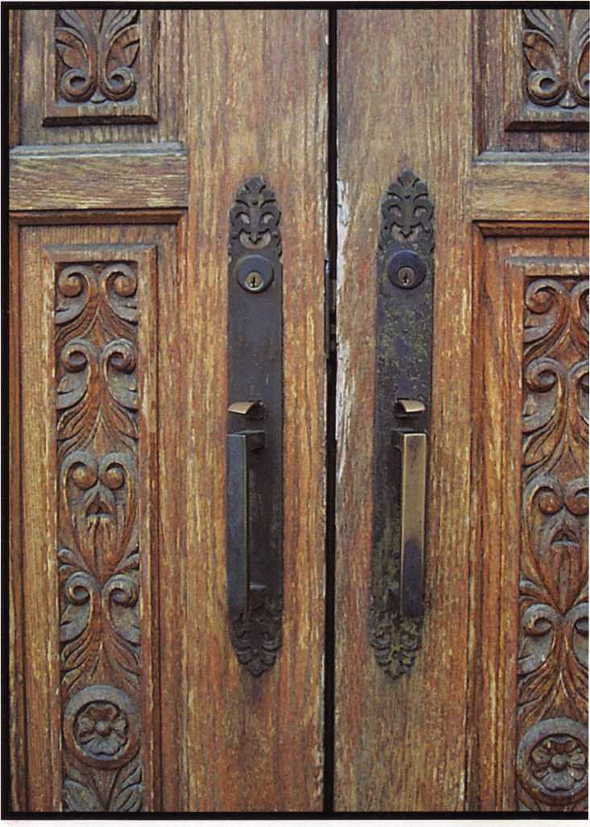

Plus:

New DoorJak from Hardnox • ScanLock's ScanProx SP-007 An NKL Spoils the Party • Red Wafer Tells All • And More



Pick Up Some Players

Attention Current Members! As the best security pros in  
the world, you play a vital role, in making ALOA what it  
is. You make our industry hyni, and we're going to  
prove it this year by offering you more benefits thpn  
ever. For the entire calendar year of 2002, those who  
recruit new members will receive special gifts from  
ALOA. We're asking you to prove you're a pro by sup-  
porting the only professional organization that exists to  
help educate, protect and promote security profession-  
als in America and beyond. Here are some of the  
details of our campaign:

**For New Members!**

All newly recruited members receive a useful ALOA  
11-piece pick set from LAB, plus our stirring "ALOA  
Locksmiths Secure America" decal for the shop or van.

**For Current Members Who Recruit!**

1 new member: The useful ALOA 11-piece pick set  
from LAB.

5 new members: A handsome ALOA Polo Shirt (w/  
stitched logo)

10 new members: LAB'S great Schlage/Kwikset  
Combination pin kit - plus membership in the ALOA  
President's Club, with your choice of a dazzling ALOA  
ring or a classic ALOA blazer (plus a periodic listing  
in Keynotes).

**For Chapters and  
Affiliates Who  
Recruit!**

If your chapter gets 15  
new members: ALOA will  
send instructors out to  
your site for two free days  
of ACE classes FREE OF  
CHARGE! Plus, the chap-  
ter or affiliate that recruits  
the most new members  
gets three free convention  
packages for our blowout  
show in sparkling Las  
Vegas in July of 2003!

Don't pass up this fantas-  
tic chance for these giftat  
free giveaways, ah ™  
expanded group of peers  
with whom to learn and  
grow, and the same  
fantastic education,  
protection and promotion  
ALOA has been providing  
for our great profession  
for almost 50 years! Call  
us today at 800/532-ALOA

(2562) for more informa-

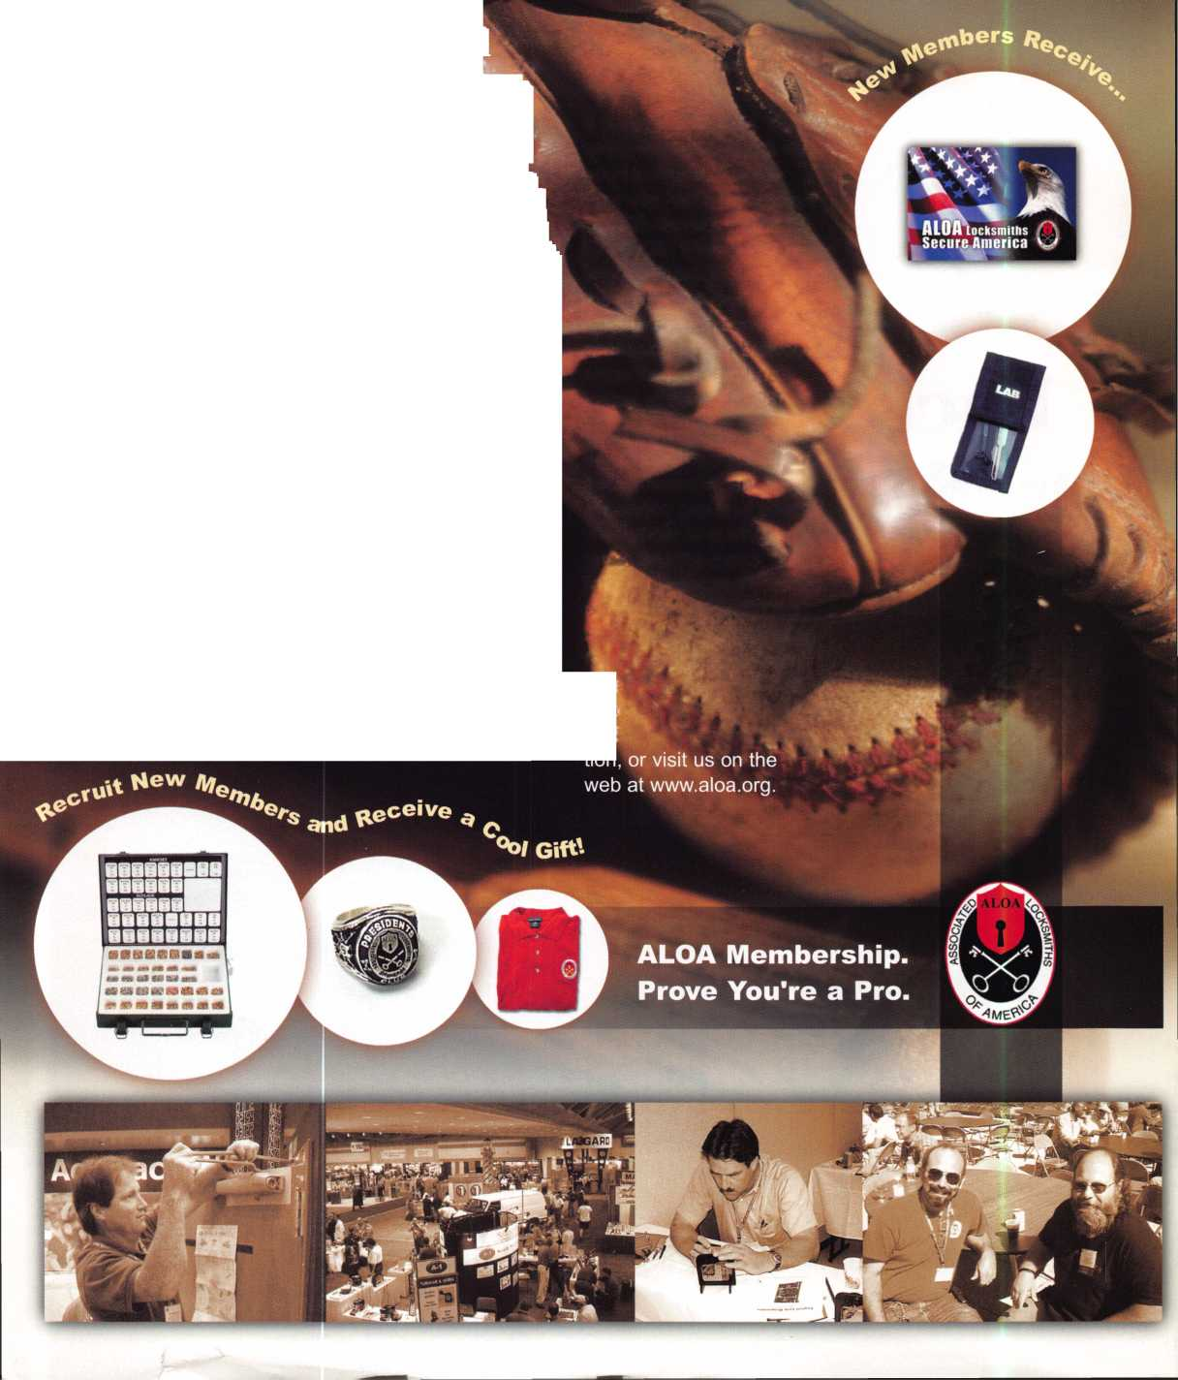

SSil

**\*\* *e^6S8?°rtate8oL^**

^SS^*"*

**Jump ahead of the competition at**

**warp speed and see your profits soar.**

**Hickok’s New Generation STAR transports you with the factory tool for programming keys to  
Ford-Lincoln-Mercury and Mazda vehicles with passive anti theft systems (PATS).**

**^ Program vehicle keys through Model Year 2001 with Hickok’s NGS Model 800-8LA-$1995 ^ Update your existing software-the 2001 Complete New Model Ford Software Update Model 80LA-$895**

**HICKOK**

**800/342-5080**

NCORPORATED

uuuui.hickoK-inc.com

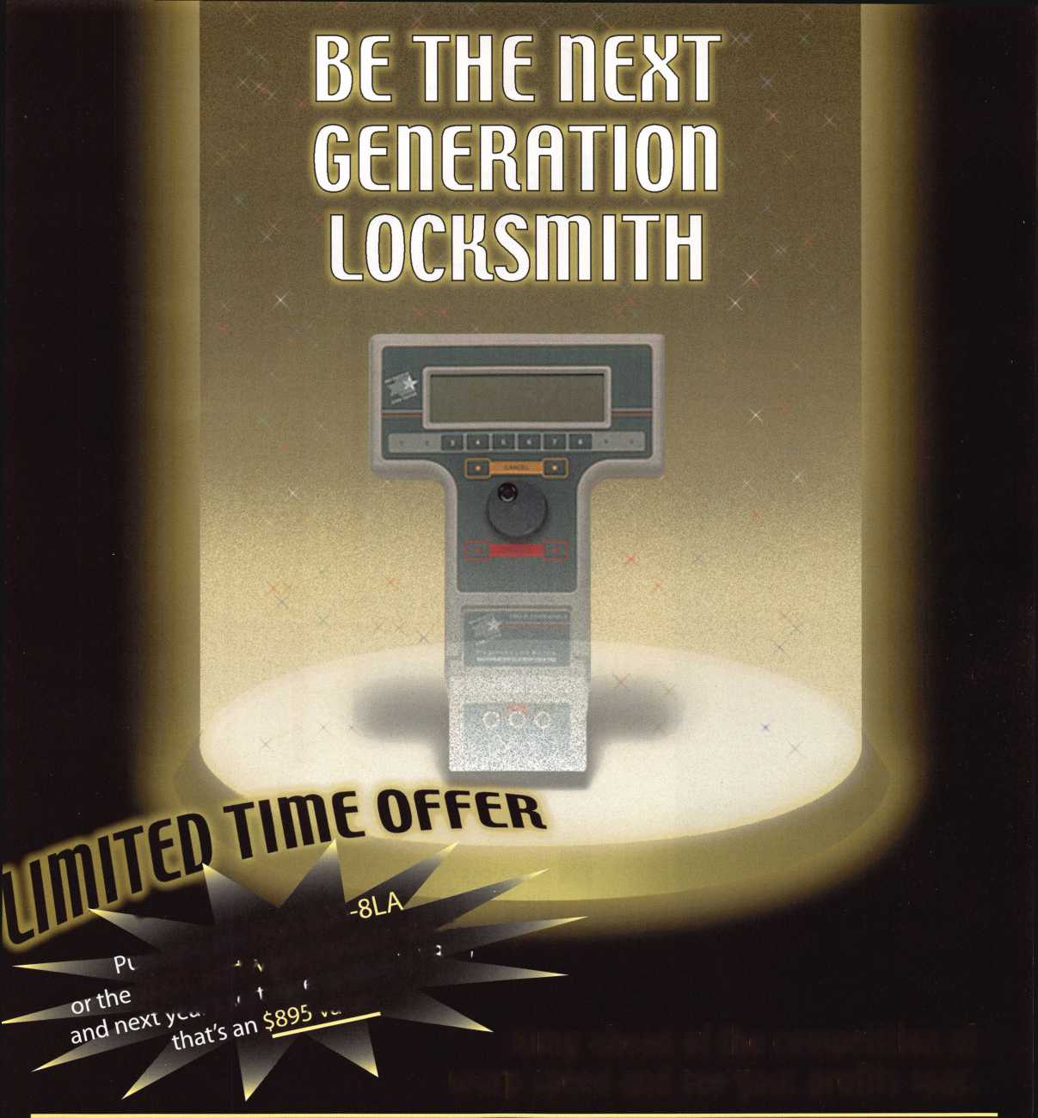

**features**

12

COVER

History: Looking Back to See Forward Merritt Perkins, RL Industry Veteran Merritt Perkins, RL, takes us on a journey into the past, with an amazing stop along the way in the late 1970s, always keeping his eye on tomorrow.



BASIC LOCKSMITHING

By Lee Griggs

Door Jak shows you that hanging doors doesn't have to be a three-man job, and it doesn't have to be a backbreaking seige.

|  |  |
| --- | --- |
| **_d** | **'I**  **epartments** |
| 4 | President's Journey |
| 6 | Upcoming Events |
| 8 | Applicants |
| 11 | Core |
| 34 | Legislative Update |
| 36 | Classifieds |
| 38 | Associate Member Listing |
| 40 | Back Page |
| **L** | **J** |

**20**

ACCESS CONTROL By Lee Griggs

Scan Lock from Scan Prox is the latest access control item that combines several of the features customers are looking for in an electronic locking device.



SAFES

An NLK Spoils the Party By Greg Perry, CML, CPS

Trying to eat cake and ice cream at your daughter's birthday party never seemed so tough. Until this tricky safe came along.

Check out what it took for the author to get back home.



AUTO By Red Howell, CRL

Red Howell's crazy wafer cartoon brings you inside the guts of one of the most common auto lock types.



BUSINESS

Flip Side of the Coin By Clare Cohen, CML

Whether it's bang or bust, sound business fundamentals can help keep you and your business pain-free.

**Visit**

**our we**

b s i t e at

**WWW**

a I

**oa.org**

Keynotes • January 2002

**executive**



Editor

Jim DeSimone.

Additional contact information for the ALOA Board and most Keynotes authors is available through "Locksmith Search'" on the ALOA Web site- [www.aloa.org](http://www.aloa.org) or by contacting the ALOA office at 3003 Live Oak Street; Dallas, TX 75204; (800)532-2562; FAX (214)827-1810; e-mail [aloa@aloa.org](mailto:aloa@aloa.org).

Operations/Membership Manager

[editor@aloa.org](mailto:editor@aloa.org) Mary May [mary@aloa.org](mailto:mary@aloa.org)

Technical Editor

David Lowell, CML, CMST [david@aloa.org](mailto:david@aloa.org)

Director of Information Technology

Randy McChristian [randy@aloa.org](mailto:randy@aloa.org)

Editorial Advisor

John D. Cannon, CML [jdcannon@worldnet.att.net](mailto:jdcannon@worldnet.att.net)

Art Director

Betty Henderson [betty@aloa.org](mailto:betty@aloa.org)

Advertising Sales

Susan Haverkamp e-mail: [adsales@aloa.org](mailto:adsales@aloa.org)

121 Davis Street Nacogdoches, Texas 75961 Phone: (936) 569-7172 VoiceMail: (208) 248-8893

Executive Director

Charles W. Gibson, Jr., CAE [charlie@aloa.org](mailto:charlie@aloa.org)

Convention & Meetings Manager

Kelly Carr, CMP [kelly@aloa.org](mailto:kelly@aloa.org)

PRP/Education Manager

David Lowell, CML, CMST [david@aloa.org](mailto:david@aloa.org)

Government Affairs Manager/

Chapters & Regional Associations Liaison

Tim McMullen [tim@aloa.org](mailto:tim@aloa.org)

Comptroller Kathy J. Romo

Network Specialist Greg Jackson

Membership Coordinator Shelly Jett

Convention & Meetings Assistant

Karen Lyons [karen@aloa.org](mailto:karen@aloa.org)

PRP/Education Coordinator Ashley Manson

Accounting Coordinator Kathy Green

Mail Room Coordinator Humberto Cerda

Receptionist Alin Valdez

Contributors

Jerome Andrews, CML Paul Chandler, CRL Claire Cohen, CML Brian Costley, CML, CMST Ray D'Adamo, CML

Sal Dulcamaro, CML Billy Edwards, CML Dan Graffeo, CRL,CMST A.J. Hoffman, CML Jeff Nunberg, CML, CMST

Mike Oehlert, CPL, CPS Randy Simpson, CML Robert Stafford, CML Dave Thielen, CML Greg Perry, CML,CPS

Tom Seroogy Charles Stephenson, CPS Dennis Watanabe, CML, CMST

Mission Statement: The Associated Locksmiths of America, Inc. is dedicated to enhancing the professionalism, education and ethics among lock­smiths and those in related sectors of the physical security industry. With approximately 10,000 members in the United States, Canada and the free- world, ALOA is poised to help members obtain the knowledge, the strength, and the confidence to perform their role in the physical security field with pride and dignity. But it is only through active involvement and participation that ALOA can fully achieve its potential—and can help members to achieve theirs.

Policies: Keynotes® is the official publication of the Associated Locksmiths of America, Inc. (ALOA). Keynotes® acts as a moderator without approving, disapproving, or guaranteeing the validity or accuracy of any data, claim, or opinion appearing under a byline or obtained or quoted from an acknowl­edged source. The opinions expressed by the authors do not necessarily reflect the official views of ALOA. Also, appearance of advertisements and new products or service information does not constitute an endorsement of products or services featured by the Association. The Association does not accept responsibility for the inaccuracy of any data, claim, or opinion appearing in this publication, due to typographical errors on the part of the authors, Association staff or its agents.

Editor's Note: This publication is designed to provide accurate and authoritative information in regard to the subject matter covered. It is provided and disseminated with the understanding that the publisher is not engaged in rendering legal or other professional services. If legal advice and other expert assistance is required, the services of a competent professional should be sought.

Authors' Payment: Payment for eligible submissions to Keynotes will be based on the following criteria: topic, time spent and past contributions. Authors who regularly submit to Keynotes® are generally paid a higher rate. The latter is especially true of authors who write to fit specific editorial needs and submit said copy by Keynotes® deadlines. As a general guideline: Average payment for a 750 word, business or 'light' technical article would be $200. Payment for a 1500 word article involving significantly higher time and research efforts would be $400.

Payment will not be offered for articles submitted by ALOA employees or members of the ALOA Board of Directors (unless material is of a technical nature), nor for articles submitted by a company that promote that company's products or services. ALOA reserves the right not to pay for articles sub­mitted by an individual(s) that promote a particular company's products or services.

Disclaimer: The Associated Locksmiths of America, Inc., (ALOA), reserves the right to refuse any article for any reason. Additionally, ALOA reserves the right to edit, amend or modify any article submitted for publication in order to preserve technical accuracy, clarity, fairness or grammatical cor­rectness. ALOA will make the best efforts to notify the author of any changes. The extent of ALOA's liability for any article or information contained therein will be a notice of correction or retraction in the next possible issue.

Keynotes® (ISSN 0277 0792) is published monthly except for the combined June/July issue by The Associated Locksmiths of America, Inc., 3003 Live Oak St., Dallas, TX 75204-6186. Telephone: (214) 827-1701; FAX (214) 827-1810; e-mail [aloa@aloa.org](mailto:aloa@aloa.org). Subscription rates for members—$15.00 per year. Second class postage paid at Dallas, Texas. POSTMASTER: Send address changes to: Keynotes, 3003 Live Oak St., Dallas, TX 75204-6186. © Copyright 1999, All rights reserved. No part of the contents may be reproduced or reprinted in any form without prior written permission of the pub­lisher.

President

Randy Simpson, CML  
(713) 780-7026  
[president@aloa.org](mailto:president@aloa.org)

Secretary

John D. Cannon, CML  
(703) 9606413  
[jdcannon@worldnet.att](mailto:jdcannon@worldnet.att). net

Directors, Northeast

John C. Magee, III  
(856) 845-3434

Peter Sarailian, CRL  
(201)947-6291  
[psarailian@yahoo.com](mailto:psarailian@yahoo.com)

William L. Young, CML  
(610) 647-5042

Directors, Southeast

Vincent Formon, CML, CPS  
(901)324-2910

Donald E. Rule, CML  
(601) 324-2658  
rulecml@ebicom. net

Directors, North Central

Mark E. Blum, CML, CPS  
(517)482-5809  
[mblum@arq.net](mailto:mblum@arq.net)

John Soderland, CML, CMST  
(414) 327-5625  
ncdi rector@aloa .org

Director, South Central

Randy L. Simpson, CML  
(713) 780-7026

Directors, Southwest

Gordon R. Racine, CML  
(719) 384-4707  
swd i rector@aloa. org

Julie McCluney, CRL

(714) 636-5652  
swdirector@aloa .org

Director, Northwest

Scott L. Henke, CRL, CPS  
(907) 248-3785  
[action@alaska.net](mailto:action@alaska.net)

Director, Associate Members

David F. Matthies  
(727) 541-5536  
[dmatthies@southernlock.com](mailto:dmatthies@southernlock.com)

Trustees

Johnj. Greenan, CML, CPS  
(773) 486.2030

Dallas Brooks  
(334) 826-8990

David M. Lowell, CML, CMST  
(800) 532-2562

Edwin Toepfer, RL  
(416) 225-5589

Past Presidents

1999-2001 John Greenan, CML, CPS  
1997-1999 Dallas C. Brooks  
1995-1997 David Lowell, CML, CMST  
1993-1995 Breck Camp, CML  
1991-1993 Henry Printz, CML  
1989-1991 Evelyn Wersonick, CML, CPS  
1987-1989 Leonard Passarello, CPL  
1985-1987 Joe Jackman, CML  
1983-1985 Stanley Haney, CPL  
1981-1983 Louis LaGreco, CPL  
1979-1981 John Kerr, RL  
1977-1979 Clifford Cox, CML  
1974-1977 Charles Hetherington  
1972-1974 Gene Laughridge  
1970-1972 William Dutcher, RL  
1968-1970 Constant Maffey, RL  
1966-1968 Harold Edelstein, RL  
1964-1966 William Meacham  
1962-1964 Robert Rackliffe, CPL  
1960-1962 Edwin Toepfer, RL  
19561960 Ernest Johannesen

Keynotes



|  |  |  |  |
| --- | --- | --- | --- |
| p r e s i < | d e | n 1 | 1 s |
| j o U 1 | ■ n | e y | **r** |

Hello members,

Competition is the driver in the market place. Will you enter the competition, or be left at the starting line? Best Access Systems is located in Indianapolis. The same place is home to the famous Indy 500 (also known as the Brickyard). After years of direct marketing, Best is entering the race. A new program is being tested that will allow locksmiths to buy direct from Best. Dubbed "Supersmith," Best is soliciting the best of our industry to participate in a marketing test program. The first wave of dealers is currently being signed up to buy direct­ly from the factory in Indy. It resembles somewhat of the same flavor of Medecos first offer­ing of factory direct sales. Pricing also resembles discounts and shipping programs simi­lar to Medeco's offering.

Best's market share in most populated areas is somewhere around 20 percent. From a mar­keting position, they have done a good job of promoting their products. So somewhere in this mix is a drive to expand, or to complement this effort. It is definitely out of their current box. It could heat up the race a bit. From a two horse race, to the entry of a dark horse.

Best's history has been one of isolation. Because of their aggressive direct sales team, oth­er manufacturers and locksmith dealers had little or no interaction with them. To the extreme, many considered them to have an unfair advantage over them and their product offering. One thing is true: Best always had total control of the product and the customer. The Best sales model is one that allows products to flow to the customer in a seamless environment. Sears accomplished this by their customer satisfaction guarantee. Best was able to take their products to market and manage the customer at the same time.

So the reason for the competition is the marketplace. They love to see a good race. Gen­erally the cars get faster and the whole level of all in the race is elevated when there are many fast cars. I think the cars will be getting a little faster now.

Gentlemen (and Ladies) — start your engines!

Randy Simpson, CML

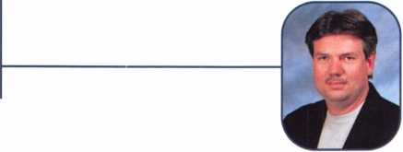

Keynotes • January 2002



***Visit our Website on  
www. stamcctv. com***

**THE COMPLETE**

**CCTV PROGRAM ON CD-ROM  
FOR STAFF TRAINING AND**

**PRODUCTIVITY ENHANCEMENT**

STAM **Insight** has been  
developed to enhance CCTV  
skills and productivity with  
many different uses.

Productivity

**90** System Drawing  
**90** Estimation  
**90** CCTV Training  
**90** CCTV Reference  
**m** Sales/Demo  
**90** System Design  
**90** Staff Evaluation

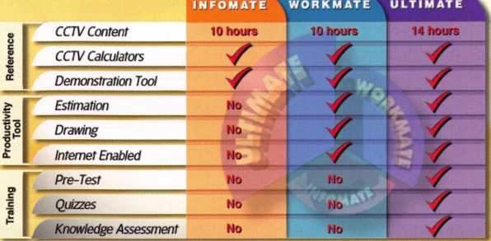

**Sold in Over 50 Countries**

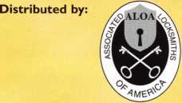

3003 Live Oak Street  
Dallas,Texas 75204

Name:

Job Title:

Organization: Address:

.Zip/Postcode, .e-mail

Fax: ( )

**. |jj**

COPYRIGHT © 1996 Security Training and Marketing Pty Ltd. All rights reserved ACN 057 006 541

Country

Tel: ( )

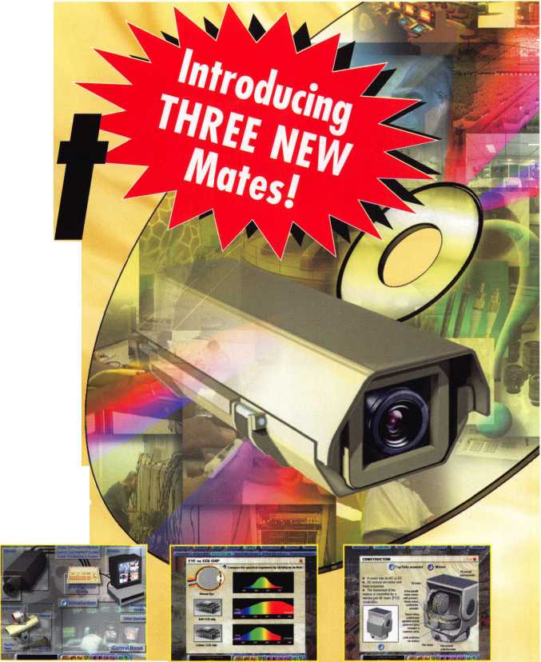

**JUNE ■ MAY ■ APRIL ■ MARCH ■ FERUARY ■ JANUARY**

**upcoming**

1 1-13

Wyoming locksmith Association Winter Meeting, Education Classes and Annual Banquet Day's Inn Casper, WY Reservations (307) 234-1159 Class Information: Gene Ficek, CPL (605) 642-4542

17

Florida West Coast Locksmith Associa­tion (FWCLA) • General Meeting 8pm (Financial Mgt. w/Charles Crabtree) Temple Crest Civic Center 512 Miller Ave. • Tampa FL Contact: Rob Curry (727) 849-1812

19-20

ACE Classes • Foreign Auto Butte, MT • Montana Chapter of ALOA • Todd Rasmussen, CRL 406-883-2950 • 406-883-2950

21-26

ACE Classes • Basic Locksmithing Appleton, Wl • Fox Valley Technical Jerry Antoon • 920-735-2406 920-735-2414 [antoon@foxvalleytech.com](mailto:antoon@foxvalleytech.com) [www.foxvalleytech.com](http://www.foxvalleytech.com)

|  |  |  |  |  |  |
| --- | --- | --- | --- | --- | --- |
| 8 | 1 | 2-17 | 16 | 21 | 12 |
| PRP • Dallas, TX |  | A Convention, at Omni Hotel - | PRP • Georgia Chapter of | Florida West Coast Locksmith | Fox Valley Chapter of ALOA |
| Ashley Manson | Ri | :hardson, Texas. For more | ALOA • 10 a.m. | Association (rWCLA)  Gpnprn AApptinn finm (Ynlp | Membership Meeting |
| (800) 532-ALOA (2562) | in | ormation: Michelle Spears | Chamblee, GA | Vvt ICI Ul JYlUvitl IU vUIII | tUIC  Locks w/Bill Williams) | 6pm • Columbus Club |
| [education@aloa.org](mailto:education@aloa.org) |  | '9-297-2413 | Contact John Elliott, CML, CPS | Temple Crest Civic Center | Appleton, Wl • Contact: |
|  |  | ■vw.texaslocksmiths.org | 770-309-7574 | 512 Miller Ave. • Tampa FL | John Engel (731)5400 |
|  |  |  |  | Contact: |  |
|  |  |  |  | Rob Curry (727) 849-1812 |  |

3

Southern Trade Show  
Southern Lock & Supply  
[www.southernlock.com](http://www.southernlock.com)  
7:30pm - LAB Class



PRP • Dallas, TX • Ashley Manson (800) 532-ALOA (2562) [education@aloa.org](mailto:education@aloa.org)



5-7

ISC EXPO/West at the Las Vegas Convention Center in Las Vegas, Nevada. For more information: <http://www.iscwest.com>

18-23

ACE Classes • Basic Locksmithing Appleton, Wl • Fox Valley Technical Jerry Antoon • 920-735-2406 920-735-2414 • [antoon@foxval- leytech.com](mailto:antoon@foxval-leytech.com) • [www.foxvalleytech.com](http://www.foxvalleytech.com)

8-13

PRP* SAFETECH 2002 • Reno NV Contact ALOA • (800)532-2562 o (214)827-SAFE (7233) [www.savta.org](http://www.savta.org) [convention@savta.org](mailto:convention@savta.org)

18

Florida West Coast Locksmith Associa­tion (FWCLA) • General Meeting 8pm (Detex w/Accent Marketing)

Temple Crest Civic Center 512 Miller Ave. • Tampa FL Contact: Rob Curry (727) 849-1812

1

18-21

PRP«20 ACE Classes and PRP Somerset, NJ Dan McGlynn, CML 973-267-8884 973-538-1588 [dfmcml@home.com](mailto:dfmcml@home.com) [www.mlanj.com](http://www.mlanj.com)

19-21

Minnesota Chapter of ALOA PRP Education weekend, Maplewood, Minnesota.

For more information: Michael Mattern, CRL (952) 544-3399

10

PRP • Dallas, TX • Ashley (800) 532-ALOA (2562) [education@aloa.org](mailto:education@aloa.org)



PRP • Dallas, TX • Ashley Manson (800) 532-ALOA (2562)



|  |  |  |
| --- | --- | --- |
| **July** | 13-14  DHI Convention and Expo, Chicago, Illinois.  For more information: [www.dhi.orc](http://www.dhi.orc) |  |
|  |  | |

16

Florida West Coast Locksmith Associa-  
tion (FWCLA) • General Meeting 8pm  
(Don-Jo w/Buddy Brown SBS Assoc.)

Temple Crest Civic Center *512 Miller

Tampa FL • Contact: Rob Curry

(727) 849-1812

20

Florida West Coast Locksmith Associa­tion (FWCLA) • General Meeting 8pm Temple Crest Civic Center 512 Miller Ave. • Tampa FL Contact: Rob Curry (727) 849-1812



18

Florida West Coast Locksmith Associa­tion (FWCLA) • General Meeting 8pm (Steel Craft Doors w/Steve Puleo l/R) Temple Crest Civic Center 512 Miller Ave. • Tampa FL Contact: Rob Curry (727) 849-1 812

22-28

ALOA 2002

Rosemont, IL • Contact ALOA (800) 532-2562 • [www.aloa.org](http://www.aloa.org) [convention@aloa.org](mailto:convention@aloa.org)

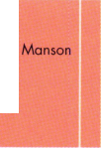

**FEBRUARY ■ JANUARY I DECEMBER ■ NOVEMBER ■ OCTOBER ■ SEPTEMBER ■ AUGUST**

**events**

■■■■■■■■■■■■■■■■■

14-16

ISC EXPO/East, Orlando, Florida.

For more information: siaontine.org

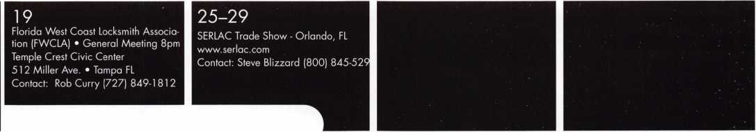

14-19

ACE Classes • Basic Locksmithing Appleton, Wl *Fox Valley Technical Jerry Antoon • 920-735-2406 920-735-2414 • [antoon@foxval- leytech.com](mailto:antoon@foxval-leytech.com) • [www.foxvalleytech.com](http://www.foxvalleytech.com)

17

Florida West Coast Locksmith Associa­tion (FWCLA) • General Meeting 8pm Temple Crest Civic Center 512 Miller Ave. • Tampa FL Contact: Rob Curry (727) 849-1812

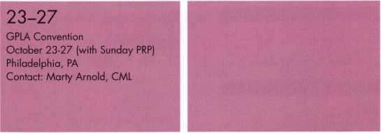

Florida West Coast Locksmith Associa­tion (FWCLA) • General Meeting 8pm Temple Crest Civic Center

512 Miller Ave. • Tampa FL Contact: Rob Curry (727) 849-1812



**Don’t Miss these  
ALOA Events!**

JANUARY 19-20, 2002

ACE Classes • Foreign AutoButte, MT • Montana Chapter of ALOA • Todd Rasmussen, CRL 406-883-2950 406-883-2950

JANUARY 21-26, 2002

ACE Classes • Basic Locksmithing Appleton, Wl Fox Valley Technical • Jerry Antoon 920-735-2406 • 920-735-2414 a n too n@foxva 11 ey tec h. co m www. foxva I ley tec h. co m



Homer

Margaret A. Brown

CA

San Francisco

Jason W. Prior

Scoffs Valley

Stephen R. Reeder

CT

New London

Michael E. Harrington

FL

Kissimmee

Freddy Pena

Sponsor: Mike Montalvo

Miami

Scott G. Bean

Sponsor: Robert W. Duman Sr, CML

Gustavo R. Lovato

IA

Des Moines

Jesse M. Escovedo

Sponsor: Ronald A. VanElsen CRL

IN

Indianapolis

Douglas Etheridge

Sponsor: Billy B. Edwards Jr, CML

Lebanon

Penny Golden

KY

Lexington

Robert A. Hillard

Sponsor: James J. Cawby CML, CPS

MA

Boston

Richard A. Cormier

Holyoke

Michael A. Nelson

Sponsor: Henry A. Fusari

North Billerica

Frank Squibb

Sponsor: Robert G. Day

Winchester

Mark D. Mercauto

Sponsor: Carmine A. Mercauto CRL

Ml

Fowlerville

Maurice Aquilina

Redford

Clifford G. Cranick

Sponsor: Robert M. Massard CRL,AHC

Masri Youssef

NC

Asheville

Emily N. Ander

Sponsor: William G. Chatham

Charlotte

Joe DePaola

NJ

Burlington

Jeffery F. Gordon

Butler

Oldrich Kubat Jr, RL

NM

Albuquerque

James D. Anders

Sponsor: Warren H. Rooks

NV

Gardnerville

Art R. Grobben

Sponsor: William H. Gunkel RL

NY

Hamilton

Freman M. Chase

Moriches

Alan Volo

Sponsor: Alan B. Seliger RL New York

Rhett Butler

Sponsor: Gale O. Johnson CPL

OH

Brookville

Bruce W. Jordan

OR

Hillsboro

D Douglas O'Connor



Altoona

William R. Friedenberger

David E. Claar

Sponsor: Paul R. Frederick

TX

Irving

Jorge I. Ruiz

WA

Seattle

James King

Sponsor: Bonita Woo

Canada

ON

Orangeville

Harold F. Doan Jr

Sponsor: Leonard J. Passarello CPL

Scottland

Tollcross

Glasgow

Mario Kerr

Sponsor: Ken Dale

These applicants are scheduled for clearance as members of ALOA. The names are published for member review and comment within 30 days of this Keynotes issue date, respectively, to ensure applicants meet standards of ALOA's Code of Ethics. Protests, if any, should be addressed to the Membership Department and must be signed. Active Membership applicants (a) have worked in the industry two or more years. Allied Membership (AL) applicants are not locksmiths, but work in a security-related field. Apprentice Membership (AP) applicants have worked in the industry less than two years.

Keynotes • January 2002

BOARD

nominations

**What ALOA Board Positions Are Open and Where Am I Qualified to Run?**

There are currently seven regional directors positions open for election in addition to the position of Secretary. ALOA members now elect the directors from their own regions. Only ALOA members from a region are eligible to run for the open posi- tion(s) in that region. And only mem­bers from the nominee's region will receive a ballot to vote for that can­didate. Members from any region are eligible to run for the Secretary position. You must have been an ALOA member for at least three years to run.

The following vacancies will exist for the election to be held before the

|  |  |
| --- | --- |
| ALOA 2002 Convention. | |
| **Northeast** | **three directors** |
| **South Central** | **one director** |
| **Northwest** | **one director** |
| **Asian** | **one director** |
| **European** | **one director** |
| **Secretary** |  |
| If you have any questions, please | |
| contact Charles | Gibson at (800) |
| 532-2562 or email | |
| [charlie@aloa.org](mailto:charlie@aloa.org). | |
| On this page you will find the | |
| required nomin | ation petition and |
| the on the following page, the nom | |
| nation form. |  |
| The following is | the number of |
| signatures required for each | |
| Board position: |  |
| **Secretary** | **25** |
| **Northeast** | **22** |
| **South Central** | **7** |
| **Northwest** | **4** |
| **Asian** | **3** |
| **European** | **4** |

Associated Locksmiths of America, Inc.

Board of Directors Nomination Petition

Please print legibly or type. This form can be reproduced if needed.

I, the undersigned, request that be placed on

(name of nominee and member number)

the ballot for for the election to be held at

(position for which individual is being nominated)

the special meeting of ALOA members to be held in 2002 or any adjournment thereof. I am eligible to vote in the region.



PRINTED NAME



PRINTED NAME



PRINTED NAME



PRINTED NAME



PRINTED NAME



PRINTED NAME



PRINTED NAME



PRINTED NAME



PRINTED NAME



PRINTED NAME

11

PRINTED NAME

12

PRINTED NAME



PRINTED NAME



PRINTED NAME



PRINTED NAME



PRINTED NAME



PRINTED NAME



PRINTED NAME



PRINTED NAME



PRINTED NAME

21

PRINTED NAME

22

PRINTED NAME



PRINTED NAME



PRINTED NAME



MEMBER #

MEMBER #

MEMBER #

MEMBER #

MEMBER #

MEMBER #

MEMBER #

MEMBER #

MEMBER #

MEMBER #

MEMBER #

MEMBER #

MEMBER #

MEMBER #

MEMBER #

MEMBER #

MEMBER #

MEMBER #

MEMBER #

MEMBER #

MEMBER #

MEMBER #

MEMBER #

MEMBER #

SIGNATURE

SIGNATURE

SIGNATURE

SIGNATURE

SIGNATURE

SIGNATURE

SIGNATURE

SIGNATURE

SIGNATURE

SIGNATURE

SIGNATURE

SIGNATURE

SIGNATURE

SIGNATURE

SIGNATURE

SIGNATURE

SIGNATURE

SIGNATURE

SIGNATURE

SIGNATURE

SIGNATURE

SIGNATURE

SIGNATURE

SIGNATURE

PRINTED NAME

MEMBER #

SIGNATURE

YOUR COMMITMENT TO ALOA BOARD SERVICE

(Please read carefully and sign where indicated.}

The responsibilities of an ALOA board member include contributing a moderate amount of personal time, and a significant degree of professional guidance and expertise to the organization.

You will be expected to come to board meetings and the annual membership meeting. You will need to be prepared to sensibly discuss matters of great importance to your profession and participate in setting policy as part of a governing body. Your course of action during your tenure on the ALOA board should be guided by fair minded, constructive goals pertaining to matters of consequence for ALOA and for the industry. Your contributions are expected to benefit ALOA as a whole, taking individual member rights and concerns into account, but free of the taint of partisan politics or personal gain.

On a practical note: ALOA board members are expected to behave and dress professionally at all times, especially when actively representing the association. ALOA board members are required to participate in two board meetings per year, of three or four days in length, one each fall and spring. Board members are also asked to attend the annual con­vention and are required to attend the annual membership meeting. Board members may also be asked on a voluntary basis, to represent ALOA at related local, state or regional functions, including serving in the ALOA Booth and otherwise promoting ALOA. When travel is required for a board member, expenses covered by ALOA include lodging, travel and a reasonable **per diem.** The Board has stipulated that assigned travel will be reimbursed at the lesser of the 30-day advance tourist class airfare in effect at the time of travel or the current per-mile rate for travel by personal automobile. Spouse expenses, including extra room charges, etc., are the individual's responsibility.

• • •

I have read and understand the above responsibilities of an ALOA board member, and agree to commit my time and energies as needed. I certify all of the information contained on this form and supporting documentation to be true and complete.

I can be contacted with questions at:

Address Phone #

Signed:

Date

Please attach a recent photograph of yourself and retain a copy of this profile for your own files. This profile and all supporting documentation should be submitted no later than April 1, 2002:

Mail to:

Nominee Profile

Secretary of the Board of Directors  
Associated Locksmiths of America  
3003 Live Oak Street  
Dallas, TX 75204-8186

Rev. 12/01



Former FBI Director to Speak at SIA Forum 2002

The Security Industry Association (SIA) recently announced that Former FBI Director Louis Freeh will headline the Security Industry Forum, to be held February 3-5, 2002 at the Westin Innisbrook Resort in Tampa, Florida. Freeh will address Forum attendees during the dinner event, held on the evening of February 4. The theme of the conference, which has become renowned for its focus on trends and solutions for end-users, deal­ers, integrators and manufacturers, is "The Digital Revolution and the Convergence of Technologies."

For more information, including cost-saving special promotions, go to [www.SecurityGateway.com](http://www.SecurityGateway.com) or [www.SIAonline.org](http://www.SIAonline.org). Or, contact Meighan Cutler at 703-683-2075 or email [mcutler@siaonline.org](mailto:mcutler@siaonline.org).

IR Intends to Acquire 30 Percent of CISA

Ingersoll Rand recently announced that it has signed a purchase agree­ment that provides for the purchase of a 30-percent interest in Italy-based CISA S.P.A. The closing of the acquisition is subject to regulatory approval as well as the satisfaction of certain other closing conditions. CISA, which was founded in 1 926, manufactures an array of security and safety prod­ucts, including locks, cylinders, door closers and panic hardware, and also markets safes and padlocks. The company operates worldwide, marketing its products under the leading brands of CISA, Bricard and CISA orraduras, and employs approximately 2,500 people. CISA has estimated annual revenues of $180 million.

"Our relationship with CISA provides a platform to pursue exciting growth opportunities," said Randy P. Smith, president of IR's Security and Safety Sector. "By combining IR's product offerings with CISA products, our com­panies can jointly offer a complete product portfolio in the Americas and in the European and Asia-Pacific markets. As a result, this agreement con­tinues IR's aggressive efforts to increase participation in global security and safety markets."

For more information, visit IR's website at [www.irco.com](http://www.irco.com).

New Certifications

Tragedy Strikes ALOA Members

ALOA member Seth Pehr had a shop in the lobby of Five World Trade  
Center in New York until the terrorist attacks of September 1 1 devastated  
his business. He lost everything. All of his customers were in the World  
Trade Center. He has not been able to get any assistance from any  
agency thus far.

If you have a donation or equipment to donate, please send it to: ALOA  
3003 Live Oak St. Dallas, TX 75204

Mailbox

"I have been a locksmith since the mid 1980s, when I learned my trade in  
the United States Air Force. I never did anything with my skills until this  
past year, when I started a part-time business out of my house. I am the  
only locksmith in a 100 square mile radius. So business is good; the cus-  
tomers are here. I was planning on joining ALOA and would still like to in  
the future. Everything was going great until my house had an electrical  
short and burned down. I lost everything and had no insurance. My  
church provided me with a place to stay, clothes and furniture, but I lost  
all my equipment, tools, locksmith instruction books, code books, etc. It will  
take me at least a couple of years to save and purchase enough equip-  
ment to service this area again. My prayer and hope is to ask if you could  
somehow ask your members if they have any extra unused equipment they  
could donate or loan to me so that I practice the profession I love. I don't  
want anyone's money - just the means to earn my own.

Thank you and God bless you,

Jeff Thomas

If you have equipment to donate, please sent it to: Jeff Thomas  
P.O. Box 371 • Marston, MO 63866

In Memory

Daniel Hill, 55, recently passed away. He was a  
long-time ALOA member who owned Hill Lock and  
Key in Bloomington, IN, for more than 25 years.  
He was also a veteran of the United States Air  
Force. On behalf of everyone at ALOA, we offer  
our sympathy to Mr. Hill's family.

CPLs

David Hallee  
Jonathan Martin  
John Whitmarsh

CRLs

Keith Bedrassian  
Michael Harrison  
Carmine Mercauto  
Lawrence Sedgwick  
William South  
Michael Staples  
Michael Sullivan  
Gilbert Wade

Waterville, ME Kilgore, TX Danvers, MA

Marblehead, MA Milford, CT Winchester, MA Haverhill, MA Portland, CT Taunton, MA Needham, MA Southington, CT



Be sure to check the ALOA website for  
late-breaking industry news:

[www.aloa.org](http://www.aloa.org)



Keynotes • January 2002



to See Forward

By Merritt L. Perkins, RL

From the time I was a small boy in the 1920s, I was interested in mechanical things. I learned the alphabet from mail order catalogs and studied the toys and tools. My father had a collec­tion of old Popular Mechanics magazines, which I prized very highly and studied, although I didn’t understand much of them.

Most of the locks in the house were mortise locks using bit keys, except one front door lock, which was a lever tumbler mortise lock that used a flat steel key. The locks on the furniture used barrel keys.

I have old tools and books that my grandfather had, including leather bound books about chemistry and philosophy from the 1850s, issues of the Scientific American including a bound volume for 1873, a book about printing and an 1899 hardware catalog. Among the old papers was an instruction sheet for the S&G combination lock from the Detroit Safe Company. The combina­tion lock is not like any other combination lock I have ever seen.

I learned the alphabet from the index of mail order catalogs and studied the toys and tools for them. My father bought a forge with a blower operated by a hand crank, an anvil, hammer, tongs and other blacksmith tools. I would start a fire in the forge and heat bars of iron and steel and shape them, but I never learned too weld with the forge. We had a small grinder operated by hand crank and I noticed that some kinds of steel would throw a bril­liant shower of sparks while others wouldn’t .

When I graduated from high school in 1932, my father suggested that I start servicing radios. I didn’t have much to work with: a jeweler’s soldering iron heated with an alcohol torch, a pair of headphones, some old pliers and screwdrivers. Gradually I got things to work with, a 0-1 millimeter micrometer and precision resistors to measure different voltage ranges and made my own case for it.

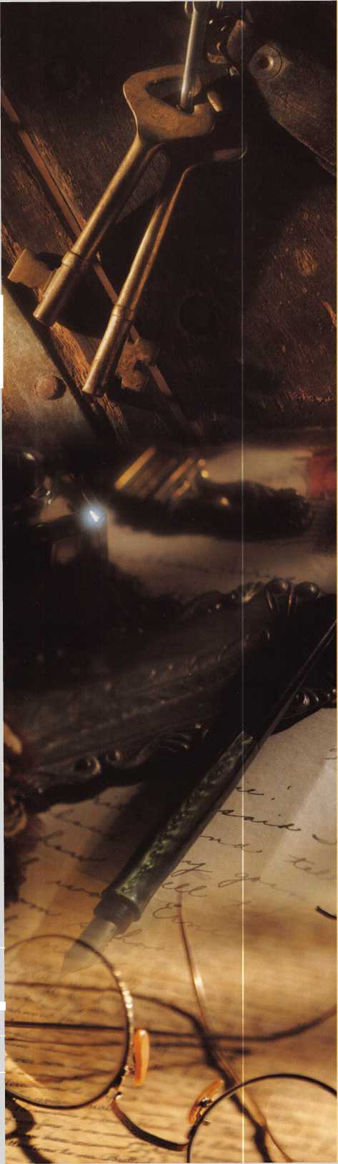

I wanted to study waveforms and when a 3 in. cathode ray tube became available in 1934 I was fortunate enough to get one and build an oscilloscope which operated from two automobile storage batteries. We charged the batteries with a gasoline engine driven generator.

I got the engine from 1915 Dodge car, overhauled it and made an alternator from another Dodge starter-generator and used it to generate AC power until the power lines came to the country.

We didn’t have any good way to measure and test capaci­tors. One night the thought came to me, “What if I apply AC voltage across two capacitors connected in series and connect the horizontal deflecting plates across one and the vertical deflecting plates across the other?” I tried it and it worked. I went on to develop this idea and built test equip­ment that I used to service radio and television sets. I used it to check the emission of vacuum tubes connected as diodes. By plotting graphs it showed things you would never know otherwise. I was young, but learning about life as a repairman.

I had a friend who was crippled and did repair work, including repairing electrical appliances and rewinding motors. After a man who cut keys and worked on locks died, my friend bought his equipment and supplies. This included an llco duplex key machine that had a rotary file and slotter for duplicating cylinder and flat steel keys, some magazines and key blanks. He threw away the magazines. There was micrometer with the sides of the anvil ground away so that you could measure the depth of key cuts. He never learned what such measurements meant. He changed combinations by rearranging the pins or using pins from old locks and filing the keys by hand.

As time went by he acquired some machinery, a drill press, lathe, and a band saw and did a little machine work.

My friend moved to a room over one of the downtown stores. I rented a room across the hall from my friend for storage, where I later serviced radios. I would often go over and visit with him and do some of the jobs that were brought to him because I liked to do them.

A locksmith from another town used to stop in from time to time and from him he learned about the use of gauge keys to cut automotive keys by code and made copies of some gauge keys. He had a few old code books.

The other locksmith suggested making some simple hand- operated key duplicating machines. My friend made several that the other locksmith sold.

My friend got to buying key blanks in quantity direct from Taylor. He numbered key blank boxes by llco key blank numbers. He would take a few blanks out of each box and put them on a shower curtain hook, then fasten several of these together with another shower curtain hook.

He worked out his own classification system, starting with whether the lowest groove was the right or left side of the blank, then how many grooves were on the other side.

He was only familiar with a few makes of locks, such as Yale. My friend taught me how to impression and shim pin tumbler locks and to smoke the key with a candle when fit­ting a key to a lever tumbler lock. When my friend became ill and was confined to bed I would go out and take care of the outside jobs and take the locks to him to work on and fit keys to. We were familiar with mortise, locks but didn’t know anything about the newer types of door locks.

In May 1968, my friend decided that he wanted to quit locksmithing, so I bought his equipment and supplies including his old llco duplex key machine and a later model made in the late 1940s, which was not very accurate. There was also a key machine for duplicating bit keys.

I have been told that hardware stores would have a large display of bit keys made at the factory. Many of these keys were made of steel. Bit key blanks to be duplicated were made of malleable iron, which is easier to cut. I subscribed to the locksmithing magazines and joined ALOA. A lock­smith who was retiring advertised his collection of maga­zines dating back to 1944 for sale and I bought them. I got catalogs from locksmith distributors and wrote to manufac­turers for information on their products. I received a beau­tifully handwritten letter from Bernard Falk, the owner of Hardware Sales & Supply Co. of Detroit. Several lock­smithing companies were owned by Falks: the Independent Lock Company, Fitchburg, Massachusets, the Dominion Lock Company of Canada, and the Fort Lock Company of Chicago.

I never advertised, but got jobs from people who knew me or knew about me. At first, I filed out keys by hand when I changed a lock combination. I decided that keys should be cut to accurate measurements and modified the newer llco duplex key machine to make it a code machine.

**13**

Keynotes • January 2002

I made a blade attachment for a micrometer so that it could be used to measure the key to bitting depth.

I measured many locks to determine the correct spacing and depths. Wiegand Jensen was manufacturing code machines and I wrote to him about information on depths and spacing. He sent me a copy of his book and com­plained that most locksmiths were not interested in cutting keys by code. I bought several milling cutters for my code machine. I had thought that a rotary file would give the smoothest cut, but this is not true.

Our town had a museum with two old safes, one quite ordinary, the other a large round safe that had belonged to the bank. It had two combination locks connected to the dials by gears. There was a time clock for each lock. Hardened rods inserted in the case would make drilling difficult, I noticed that some of the technical magazines were short of articles, so I wrote to them and they wanted me to write articles for them.

While talking with one editor, who was a department store detective, he suggested that I write to one of the stock­holders. It was Joe Zastro, and he came out from Chicago with his motor home on a Wednesday afternoon and picked me up. We stopped at his apartment house on Milwaukee Avenue where he had started business on the first floor, but now it was used for storage while he lived on the fourth floor.

Next to the apartment house was a parking lot opening into the alley and beyond that, his single floor shop with four overhead doors opening into the alley where service vehicles can be stored.

On the right was the section devoted to servicing door closers with air vises on the work benches. On the left was the section devoted to locks and keys. The section for working on Medeco locks was enclosed for security rea­sons. Joe was retired now, but his son was still employed at the shop. That evening, Joe took me to a meeting of the greater Chicago Locksmith Association, where I was intro­duced to several locksmiths.

The next morning we headed out for Madison Wisconsin to meet some leading industry people. That evening we went to Lake Mills, Wisconsin, to see where one of the technical journals was printed. I rode with the publisher so that we could talk. He gave me back issues of the magazine.

They asked us to go to St. Paul Minnesota at a convention of the Minnesota Locksmiths Guild on Saturday. We stopped at Crystal Lake, Illinois and picked up Terry Smith at his apartment. We traveled all night and Terry drove part of the time while the others slept.

Terry had taken machine shop courses in school. When a locksmith was working at his school Terry went over and watched him and the locksmith invited Terry to visit his shop. Terry spent a lot of time there and later went to Chicago and stayed in Joe’s apartment and worked in Joe’s shop. Terry had just started his own shop and made most of the furniture.

The show was pretty big, and one exhibit was of a magnet­ic key that could be inserted in a slot in the side of the door knob. A tool was available to set or change the mag­netic code on the key which used a magnetic rubber.

Another exhibit was of tubular key machines. Terry bought one that was on exhibit because he had a job waiting for it. We attended a great banquet that night.

The convention continued Sunday forenoon and while waiting for it to open, I had a chance to visit with Barney Goldberg who was representing HPC. He had once worked for the Taylor Lock Company. After the convention that afternoon, Joe took me over to visit his sister and her hus­band who owned a large machine shop. He was showing me large machines that cost hundreds of thousands of dollars from Switzerland and Germany At the back of the shop, he pointed out a milling machine and said, “We have had the least trouble with that machine of any machine in the shop.” I asked him where it was made and he went over looked and told me that it was made in my hometown.

In the center of the shop, was a large air-conditioned room with a huge black granite surface plate at least 8x12x2 feet, with numerous other surface plates and precision measuring instruments. They had been making a machine for slitting tape and he gave me a few rolls.

Back in Chicago, we visited a locksmith distributor, where I looked out the back window and saw the Chicago River. We stopped at a building on Lasalle Street where a mainte­nance man gave me an old Corbin oversize mortise cylinder with a master ring.

**14**

Keynotes • January 2002

Tuesday afternoon we drove out to Schiller Park to visit Jerry Hoffman at HPC. On a wall in the outer office were several shelves of key machines. In his large inner office, he sat behind a large desk on a raised platform. A door led into the factory.

Jerry showed us through the factory.

I recall seeing a Hardige lathe that was not in operation.

A punch press was stopped that had been punching lock picks out of a wide strip of steel. A machine was coiling give-away key rings and they slid down a wire into a barrel. I stood beside a man who was using an old Ilco code machine to cut gauge keys from original key blanks. It was equipped with a carbide milling cutter running at high speed. I would estimate that he was cutting a key every three to five seconds. As Jerry handed me one of the car­bide milling cutters he said, “Don’t drop it, they only cost five hundred dollars apiece!”

They were printing code books and Jerry gave me he set of them. He asked where our car was and said that he would carry them out to the car himself because we would not be allowed to take them out of there.

On the return trip we visited Frederick Clement and his wife Maria at their shop near the steel mills in Gary, Indiana. They kept the front door locked. They had a lot of keys to stamp the numbers on. They had a lathe and welding had been done on a safe. We learned a little about mixing safe insulation there.

All in all, a great whirlwind weekend in locksmithing, many moons ago, but unforgettable. I look forward to the same thing this summer, as ALOA brings their annual conven­tion to Rosemont, Illinois. Q



Cjet your’s  
today for

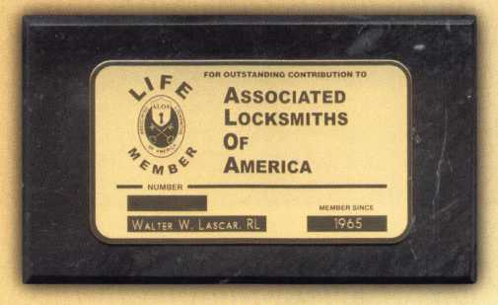

onfy $20!

*Order* onCine

*at* [www.afoa.org](http://www.afoa.org)  
or *caff*

(<Soo)s32-(ALO(A

idow you can show off your ‘ALO'A membership in styCe. ‘Regufar members and Life 'Members can simpfy gCue the membership card onto the marbfe (as shown). Don't miss out on this affordabCe, officiaC ‘ALO'A dispCay. rhe cCassy sfate-cofored marbfe comes with feft padding for your desktop or van. It can be easify mounted to show off your ALOA pride in your office/shopl T’he cost for you to dispfay your professionafpride, you ask? Onfy $20\

Keynotes • January 2002

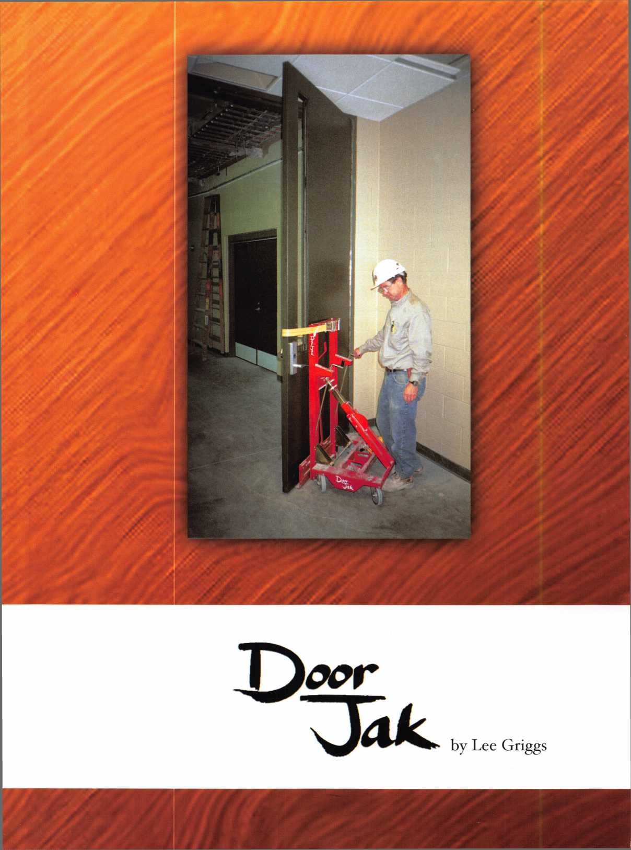

I began fumbling around as a locksmith back in the late 1950’s operating a one-man shop in Atlanta, GA. This was a “learn-it-the-hard way” period for me and I made a lot of mistakes. One big mistake was trying to wrestle glass doors by myself.

After dropping a very expensive door and wrenching my back with a heavy fire door, I learned to hire three or four people to assist me. The part I hated most was having them stand around and watch me work while I paid them. It was either that or take down the door, haul my laborers back to where I found them, and then go hunt for some more labor when I was ready to put the door back up. I finally start­ed turning down a lot of door work because of this.

Now, Hardnox LLC of Santa Barbara, CA has introduced the “Doorjak”, a door installation cart that allows one person to remove and install a heavy door easily, safely and quickly

No more laborers standing around watching you work. Now the locksmith can work with heavy and oversized doors and move them down halls, in and out of elevators and around the worksite.

The Doorjak is 21”” long at the base and 28” wide. The total height is 48”. It is collapsible for storage and ease of transport. It collapses into a 28” x 48” x 15” package and weighs approximately 150 pounds. It has three removable work trays for your tools and parts and comes with urethane wheels, two of which have locks to prevent the cart from moving around once you have it positioned. It is manufac­tured in Lincoln, Nebraska, patented and comes with a two year limited warranty. Examination of the Doorjak reveals rollers designed to protect the door finish, a built-in ratchet type attachment strap that will not scratch prefinished doors, side shifters to move the door 1” left or right for perfect hinge alignment, door height adjusters for fine tuning the door position, a hand wheel to adjust the door to the exact vertical angle and 360 degree swivel urethane casters allowing you to roll without marking the flooring.

**17**

Keynotes • January 2002

I love it! I only wish that this tool had been around years ago

when I was trying to hang doors.

The Doorjak has been tested and improved on commercial construction sites for 8 years. Using the Doorjak properly, one worker can install fire-rated, lead-lined, solid-core and commercial-grade doors* in less time, more safely and easily than two workers using conventional methods. Adjustments perfectly align the door to fit the doorjamb. Using the Doorjak as instructed can save time and reduce the risk of the worker injury, while increasing productivity. (*Up to 4’ x 7’ x **1-3/4”,** 25olbs. Additional workers should accompany larger, heavier doors.)

The Doorjak comes with full operating instructions and a presentation video. It is very simple to operate. The purpose of the Doorjak is to transport and hang doors that may be oversized and heavy. Safety is critical and using the Doorjak in a reckless manner could result in serious injury.

The locksmith wants to be sure that all bolts, setscrews and other fasteners are tightened before using the Doorjak.

Operation of the Doorjak is very simple. Secure the Doorjak in the transport position of 75 degrees making sure that the locking pins are secure. Then the locksmith and a second helper if the door is very heavy - don’t forget your back) places the door onto the carrying surface. The bottom of the door will rest on the bottom carrying lip and should be centered on the front lip and back against the plate and metal frame. Then you strap the door to the frame and off you go. If the door is leaning against a wall or is attached to a frame, you can position the Doorjak in an upright (90 degree) position and roll the Doorjak to the base of the door and slide the bottom carrying lip under the door edge making sure the door is centered on the front lip. Then you strap the door to the frame and either move it from the wall or remove the hinges (or pivots). While holding the door strapped to the Doorjak, pull the pin in the middle of the center shaft and pivot the door to the transport position. Be sure the lock pin is secure in the new position.

There is a crank assembly that allows the locksmith to secure the door to the Doorjak with the web strapping and pulling it tight to hold the door securely. There are left and right crank handles that allow you to adjust the level of the bottom lip and take the weight of the door off the floor or hinges.

If you are hanging a door, you roll the Doorjak to the doorjamb for installation. Position the door so that the hinges on the door are in line with the hinges on the doorframe and the door is 90 degrees from the door jamb (in an open posi­tion). **You** can use the left and right cranks to raise or lower individual wheels at the corners of the door to raise or lower the complete door or tilt the door to the right or left. Twisting the large screw adjustment allows the locksmith to tilt the door forward or back. When the door is accurately aligned with the jamb, attach the hinges or pivots. Once the door is attached to the jamb, release the web strap clamp and remove the strapping from around the door.

It isn’t complicated at all. If an old, retired, locksmith like myself can load a heavy fire door, move it to the door jamb, align and mount the hinges, and walk away without a slipped disk or hernia, then anyone can do it. I managed to load a commercial fire door leaning against a wall, move it down a hallway and hang the door, mounting the hinges to the door jamb—all by myself. No extra paid laborers, no back pain and the door swings just as it was supposed to. I love it! I only wish that this tool had been around years ago when I was trying to hang doors.

The Doorjak is $2,500.00 plus shipping and handling and can be ordered from the nearest distributor. Call Linty Kurtz or Kevin Patrick at Hardnox, toll free 866-687-0053. You can check out their website at [www.hardnoxllc.com](http://www.hardnoxllc.com) for the nearest distributor to you. Take it from an old locksmith who has picked up and hung many a door, the Doorjak owill save you time, money and injury and protect the door finish. If you are still doing it the old way, you really need to take a look at this tool. Q

**18**

Keynotes • January 2002

**ALOA Scholarship Foundation, Inc.  
Scholarship Application**

3003 Live Oak Street; Dallas TX 75204  
(214) 827-1701, (800) 532-2562

Please print or type **Name**

**Home Address . Home Phone**

**Present Employer .**

**Work Address**

**Work Phone**

**Position**

**PRP/STPRP Level . City**

ALOA/SAVTA#.

**State Zip _**

**Dob.**

**Educational Level**

**(years) Degree, If Any_**

**Supervisor’s Full Name . City**

**State .**

**Zip**

**Fax**

**Full Time.**

**Part Time**

**Take Home Pay_**

**Length Of Time In Locksmithing**

**Marital Status Number Of Dependents  
Classes Desired**

**Membership In Trade Associations (List By Name) .**

**Household Annual Gross Income .**

**Date Of Classes .**

**Organization Sponsoring Classes: ALOA**

SAVTA

**Other**

**Location .**

Applications will be reviewed by the ASF Selection Committee on an objective and nondiscriminatory basis. All materials and information pertaining to the applicant’s financial status and background shall be held in strict confidence by the Selection Committee.

ALOA Scholarships are granted to selected individuals desirous of entering the locksmithing field or to selected individuals already in the locksmithing field who wish to improve their professional skills through education.

Applications for classes must be received 60 days prior to the date of the class, and will be reviewed as they are submitted. Scholarships for classes at the ALOA or SAVTA convention will be awarded each year at the ALOA Scholarship Foundation meeting preceding the convention and must be received by March 1 each year.

Please attach to this form a letter stating your reason for applying for a scholarship, what you plan to do with the knowledge you obtain and any other information you feel may be helpful to the scholarship board in making its decision. In addition, attach three letters of reference from individuals who have personal knowledge of your background and character. The letters should contain their names, addresses and phone numbers. It would be helpful if at least one of these references is an ALOA or SAVTA member. All scholarship recipients will be required to provide a 3” x 5” photograph of themselves.

**Application Checklist**

Only complete applications will be considered for scholarships. An application is considered incomplete unless ALL of the above requested information is received before the deadline: 60 days prior to the classes desired, March 1 for ALOA/SAVTA convention classes. Please send this application after checking off each of the below.

* I have filled in each blank on this form.
* I have written and enclosed a letter explaining my reason for applying.
* I have enclosed three letters of reference.
* I am submitting this in time to be received 60 days prior to the date of a class or by February 1 for ALOA/SAVTA convention classes.
* I have enclosed a 3” x 5” photograph.

**Certification Of Applicant**

I certify that the information contained herein, and all supplemental forms are complete and correct to the best of my knowledge. I further certify that if I am selected as a scholarship recipient I will use the knowledge gained for the improvement, development and advancement of the lock­smithing profession. Also, if asked by an authorized ASF official, I agree to give proof of the information that I have given on this application. I also understand that this proof my include copies of my previous year’s Federal Tax Return. I also understand that if no proof is given when request­ed, I may not receive consideration for an ALOA Scholarship Award. I understand that this application is valid only for the event/class specified.

SignatureDate

Please send all completed applications to:

ALOA Scholarship Foundation, Inc. • 3003 Live Oak Street • Dallas, TX 75204

Revised 12/01

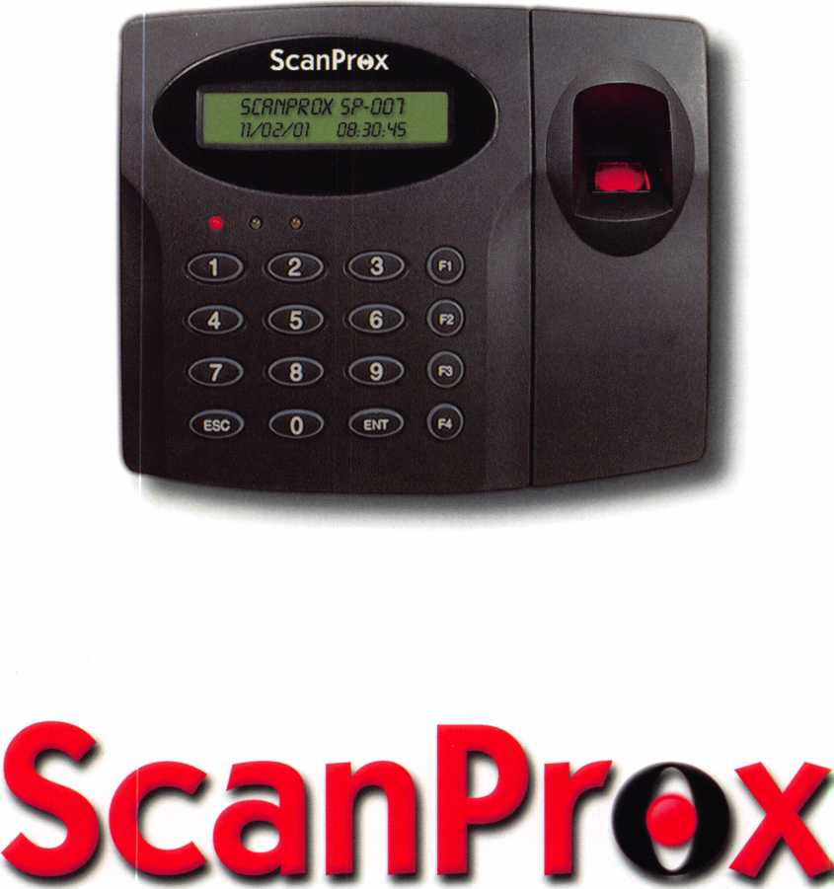

by Lee Griggs

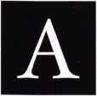

A new company has entered the electronic access control market with comprehensive access control and time & attendance in one unit. ScanLock Security Technologies, Inc., of Philadelphia, PA has developed modern systems providing multiple levels of security and services. Steve Steeves, Jr is CEO of the compa­ny and Phil Wright is Vice President of Sales and Marketing. ScanLock has factory representatives servic­ing the United States.



Keynotes • January 2002

With today’s movement toward higher security  
in the workplace, customers are asking for more  
than what mechanical locks can afford. Cell  
phones that access email and the web, portable  
radios that include TV, CD players and more,  
automobiles with satellite communications and  
GPS mapping, are leading customers to seek  
systems that provide more protection with  
more features.

I was impressed with their desire to support the  
customer’s needs and also support their distribu-  
tors. Scanlock is developing and marketing a

complete line of access and time &  
attendance products designed for ease  
of use, total security and affordability  
with improved reliability.

The UL listed ScanProx SP-007 offers  
excellent access control by allowing up  
to three levels of verification with  
Biometric, Prox, and/or PIN number.

These can be programmed by group  
and/or user. The client may choose any  
combination or all levels to ensure total  
confidence. Users won’t complain

about too much time to access the system with  
the SP-oo7’s thirty-millisecond Prox and four-hun-  
dred millisecond fingerprint read times. One of  
the problems with many biometric systems is the  
time involved in registering employees. With the  
SP-007, the user can utilize one unit to enter all  
employees into the system without wasting time  
of paid employees. It takes approximately 8 sec-  
onds to register new users into the system.

With multiple features in this type of system, the user is able to limit individual or group access to certain hours and/or days. It is very easy to add or remove individual cards. Tracking the time of access by any individual is readily provided and, if desired, the time they leave can be provided.

A door can be set to unlock or lock at certain times automatically.

The Scanlock SP-007 offers many features such  
as multiple level security, access control AND  
time & attendance, standalone AND network-  
able with flexible communication and system  
integration. For the locksmith installing access  
control systems, this unit opens up markets with  
airports, hospitals, universities, office buildings,  
manufacturing facilities and more. The buyer can  
have onsite and/or off-site installations communi-  
cating with a central computer if desired.

The system utilizes a digital time/date clock and  
intuitive Windows-based employee record soft-  
ware. It can be easily integrated with

popular payroll systems and report to  
Microsoft Office programs. A software  
development kit and source codes are  
available to any IS department wishing  
to build links to existing proprietary  
systems.

The SP-007 can function as a stand-  
alone unit (even without software) for  
up to 4500 users and 9000 events or it  
can be networked using a controller  
board for up to 10,000 users and

10,000 events. Up to 32 units can be daisy  
chained together and report to the software.

The SP-007 handles work shifts, weekends  
and holidays.

One of the nicest features of this unit is its ability  
to address RS-232/422/485 and TCP/IP communi-  
cations. The unit has 26-bit Wiegand compatibili-  
ty There are four inputs and four outputs, includ-  
ing TTLs and Form C relays allowing the user to  
integrate auto-dialers, PIR sensors, CCTV, and  
door contacts. The SP-007 also offers an addition-  
al reader port that allows the user to have anti-  
pass back functions.

This is the first product of its type allowing  
the user to program a custom “card” keyway.

The installer can create an individual “code”

I was impressed  
with their desire  
to support the  
customer’s needs  
and also support  
their distributors.

Keynotes • January 2002

21

for the installation meaning no other card will even be recognized by the system. In short, a highly secure specialized keyway for every opening controlled by ScanProx. Cards may be limited to one door in a multiple door system with other doors being pro­grammed utilizing another unique code all in the same system. Comparing ScanProx technology to the vast majority of other systems on the market today is equiva­lent to comparing digital music to AM radio. Utilizing

PSK (Phase Shift Keying) while others offer ASK or FSK (Analog or Frequency Shift Keying), ScanProx provides the strongest, fastest, and clearest signal as well as sophisticated coding.

The ScanProx SP-007 offers numerous benefits: feeling totally secure, maximizing possibilities, time saving and eliminating headaches. The unit is UL listed and flexible enough to fit almost every application. It is easily spec- able for any job.

Comprehensive Multi-door Configuration

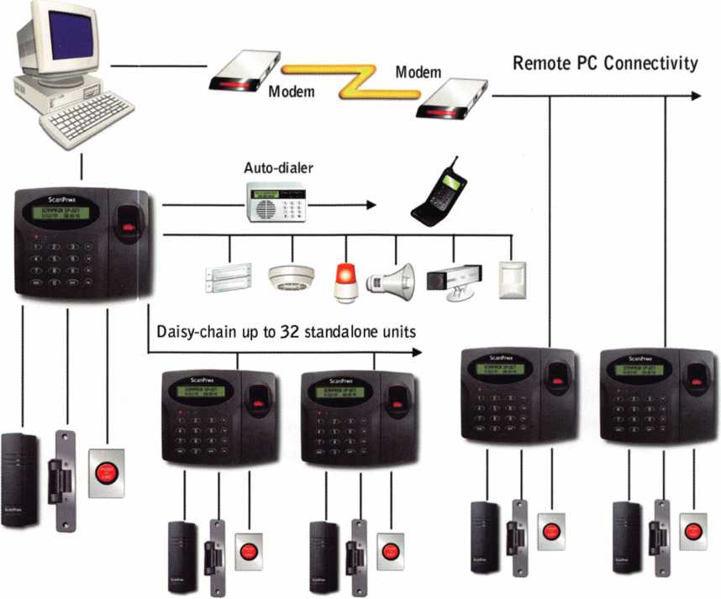

Keynotes • January 2002

Standalone Single-door Configuration

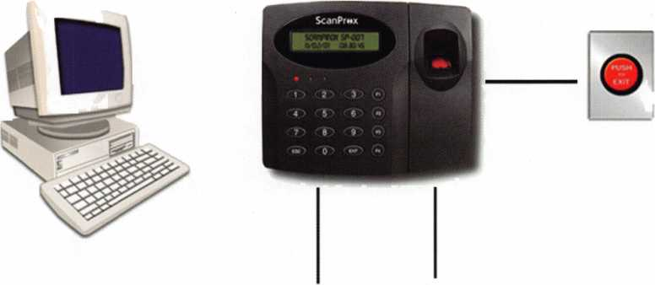

The SP-007 offers up to three levels of  
verification - biommetric, Prox,  
and/or PIN numbers. This provides  
true confidence for access control and  
employee verification.

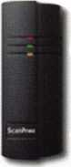

Exit Reader

The SP-007 offers amazing flexibility including: ability to program different security levels at the user/group level; wired or LAN based communica­tion; custom scheduling to address work shifts, week­ends and holidays; easy integration of many security components.

By registering new users into the system in less than 8 seconds and having user access times less than 400 milliseconds, the SP-007 saves buyers and users substan­tial time in both implementation and in daily use.

Any biometric unit becomes more reliable by adding another level of verification. Using a Prox card or PIN number to first call up the user’s file, eliminates the need to search the entire fingerprint database and essentially turns the biometric match process into a “Yes” or “No” question. The SP-007 utilizes the most secure PSK modulation for Prox and advanced biometric technology.

Last but not least, of interest to all buyers;  
the SP-007 is priced competitively with  
less robust biometric systems.

By having the ability to combine both  
access control and time & attendance,  
while providing three levels of security-

it saves time, effort, and significant amounts of money.

ScanLock Security Technologies, Inc., offers a full line of proximity readers, controller boards, stand alone RF readers, access-time & attendance systems, proximi­ty cards, tags and software packages for the buyer and installer. ScanLock also has the SP-505 stand-alone access time & attendance system utilizing Prox and PIN without the biometric feature. They also have a very affordable RF stand-alone reader SP-150S. This unit provides Prox plus keypad with 5 inputs and 4 outputs. This system operates without a controller board. ScanProx offers Prox readers with 4” and 12” range in standard and slim line utilizing controller boards.



For further information on ScanLock products, visit their web site at [www.scanlockusa.com](http://www.scanlockusa.com) or contact the company at 800-716-5033. The factory sales line is 888-4LOCKS1. □

Keynotes • January 2002

A NKL Spoils the Party

by Greg Perry, CML, CPS



Keynotes • January 2002

I have a love/hate relationship with my cell phone and this locksmith business we’re in. Most of the time when it rings after hours, it means money, but sometimes it rings at just the wrong moment. This call came as our family was heading to a birthday party for my four-year old’s friend. I loaded a scope and a couple of tools into the back of our personal car. I dropped my girls off at the party and headed to the job. My boss was already on sight with a truck. I figured I’d be on sight a few minutes, save the day and be back having cake and ice cream with my girls. Not this time. After entering the combination the handle would turn about halfway to open and stop. Was the problem in the LaGard SwingBolt; did the relock fire, or maybe some other unknown problem?

Keynotes • January 2002

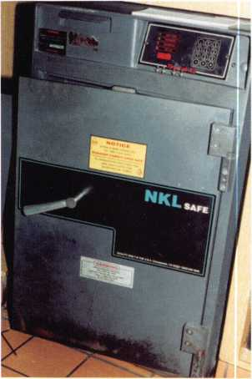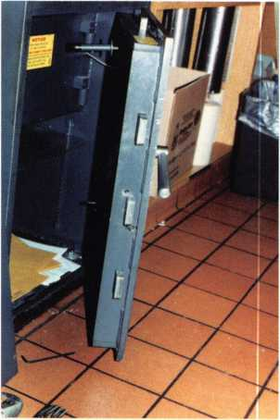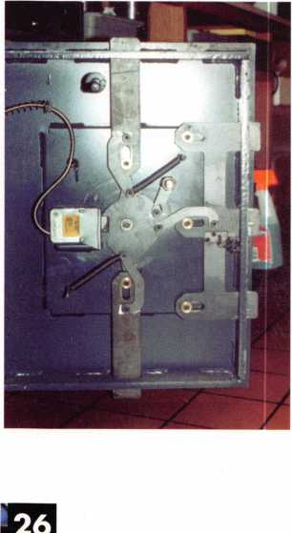

Once the safe was open, the cause of the lockout  
became obvious. The handle has a linkage arm that  
attaches to the cam to retract the bolts. Photos 4  
and 5 show the culprit. Over time, the steel of the  
arm is eaten away by the hardened steel Allen head  
cap screw. It eventually got so bad that it would no  
longer operate properly. Adding some persuasion to  
the handle might have opened it, or it could have  
snapped the handle off. I filed the groove (or rut) so  
that the safe could be used until a new part could be  
ordered and installed. I also left my hole in the side  
until the new parts could be procured, just in case it  
decided to act up again. The new part uses a bush-  
ing instead of the direct steel-on-steel that caused  
the problem this time. After installing the new part,  
I tapped the holes and installed set screws back-  
wards (the Allen to the inside) with some steel stick

epoxy to hold them in place for repair. I spray paint-  
ed the repair and wrote the invoice.

Some lockouts are more puzzling then others. They  
require thinking outside the box and, in many cases,  
an exploratory hole to aid in the diagnostics. This  
was one of those lockouts. Perhaps I should have  
drilled the hole for the bolt first, and I would the  
next time. But when dealing with malfunctions,  
sometimes the only way to proceed is slowly explor-  
ing options as you go. I never did make it back to  
the party and my kids didn’t save any cake or ice  
cream for me. I guess that’s a part of the sacrifice  
we make in this business. Q

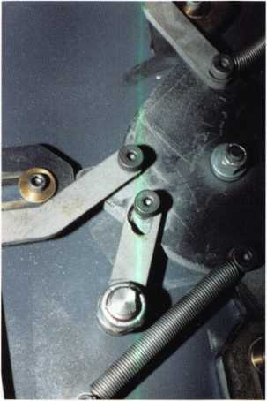

This NKL utilizes a remote mounted keypad with no hint of where the lock might  
be. I serviced this exact safe last year for a loose bolt and had taken a couple of  
quick notes on the location of the lock. The customer at that time didn’t want me  
to take any pictures of their safe. Now they wished I had taken them and offered to  
let me take them after the safe was open. Could the problem lie in the SwingBolt?

If so what would cause it to stop halfway? I quoted a price to open only and we  
(my boss and I) sat down for a soda and some fries while we waited for an answer  
from corporate. While we waited, someone from our shop brought us the notes  
I had taken last year. The relock was below the lock, but the handle sure felt like  
the cam was turning beyond where the relock should stop it. I decided to drill a  
scope hole in the side for a look around. A look around with my 7” scope revealed  
nothing unusual and my 17” scope would not manuver into the hole. The relock  
was not fired and the lock seemed to operate properly. Now what? Against my  
boss’s wishes I drilled a second hole at the center bolt and pushed. He felt we  
needed a hole through the face of the door, but where? I tapped on the bolt with

a punch and the safe opened.

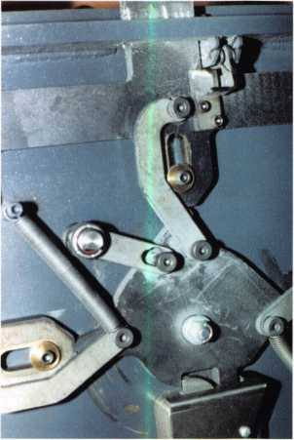

Keynotes • January 2002

***Wmm***

**list price**

Just

a Few

of Our Titles...

Learn About Basic Electricity 29.95

Spacing and Depths, vol 1 19.95

Spacing and Depths, vol 2 19.95

Filing for Dollars 29.95

Antique Padlocks 29.95

VATS Made Simple (Revised) 29.95

Guide to Transponders 79.00

2000 Transponder Update 45.00

Bread & Butter 85.00

Locks and Lockmakers of America 19.95

Learn About Electronic Locking Devices 29.95

The Best of Locksmithing, vol 1 19.95

Logical Lock Diagnostics 29.99

How to Pick Lever Locks 1 9.95

Fundamentals of Master Keying 55.00

Guide to Electronic Locksmithing 39.95

Security Solutions Locksmith Marketing Program 89.95

The Ultimate Techtips Collection 39.95

PRP Resource Guide

Locksmithing from Apprentice

to Master

Wafer Lock Reading

Door Lock Encyclopedia

- Lock Repair Manual

jfir Interchangeable Core Cylinders

Picking & Impressioning

The Lure of the Lock

High Security Safes, vol 1

High Security Safes, vol 2

Safeman's Guide, vol 13

Safe Deposit Depth and Space Manual

Safe Technician's Reference Manual

Gun Safes

Modern Safe Opening

Dave McOmie on Vault Doors, vol 1, Bank Vaults

Dave McOmie on Vault Doors, vol 2, Fire and Plate Vaults ....

Modern Safe Locks

Drilling Safes

Safe Deposit Box Service

Foreign Car Impressioning Book

Impressioning Ford and GM Side Bar Locks

Automotive Lock Servicing Update #1: GM 10-Cut Locks

Automotive Lock Servicing Update #2: GM 10-Cut Locks

Automotive Lock Servicing Update #3: GM 8-Cut Locks

GM Locks: Perfect for the Beginning Locksmith!

Ford Locks: Pin Tumbler and Ten-Cut Systems

Chrysler Pin Tumbler Locks

Chrysler Double-Bitted Locks

Toyota Split-Tumbler Locks

Basic Door Panel Servicing

Advanced Door Panel Servicing

Motorcycles on CD

The Guide to Motorcycles

Japanese High Security Auto Servicing

Revised GM Steering Column Course

Foreign & Domestic Auto Service

Auto Lock Service

The Sieveking Auto Key Guide & Illustrated Cross Reference .

Servicing Interchangeable Cores—Sargent

Servicing interchangeable Cores—Arrow, Best,

Eagle, Falcon, and Lockwood

The Ultimate CCTV Program on CD Rom

...25.00

...27.00

...19.95

...39.95

...14.95

...34.95

...45.00

...29.95

175.00

175.00

9.95

...99.00

1. 1 10.00 .59.95
2. .110.00 ...95.00 ...95.00 ...39.95 ...29.95 ...29.95 ...29.95 ...29.95 ...29.95 .29.95 ...29.95 ...29.95 ...29.95 ...29.95 ...29.95 ...29.95 ...99.00 .99.00 .29.95 .115.00 .69.95 .14.95 ...27.00 ...25.00

...25.00

.529.00

**Visit our Website or call to place your order today!  
[www.aloa.org](http://www.aloa.org) • (214) 827-1701**



Rekeying a  
Disk Tumbler  
Lock When You  
Come Up SHORT

by Red Howell, CRL

Yes, it has happened to me more than once! I was  
rekeying the ignition cylinder of a 1986 Toyota pick-  
up when I needed a #2 disk tumbler. I looked into the  
Toyota Rekeying Kit and found that the kit was out of  
#2 disk tumbler. The old way of making a #2 disk  
tumbler was to use a disk tumbler two depths deeper  
than the one you needed. In this case, it would have  
been a #4, not a #3.

The disk tumbler shown in Figure 1 is the profile of a  
standard disk tumbler used in a wafer lock. It shows  
the part of the wafer that slides on the blade of the  
key cuts. The height and thickness of this part of the  
wafer determines the depth of the cut in the blade of  
the key.

Figure 2 shows the standard #4 wafer.

Figure 3 shows the wafer with the starting and  
stopping points.

Figure 4 shows the #4 wafer finished out as the #2 wafer that you need. Q

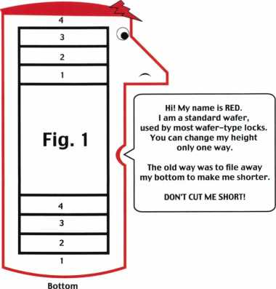

If you file away my botom,  
you will have a wafer  
that two different cuts  
will operate.

The Old Way

For example—If you  
need a #2 wafer, you would file  
away the bottom of a #4 wafer.

But if you do this,  
you would then have a wafer  
that a key witha #2 depth  
and another key with a #4 depth  
in the same position  
would operate that same wafer.

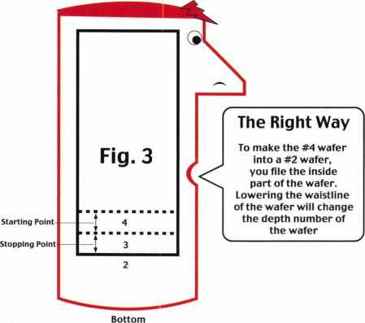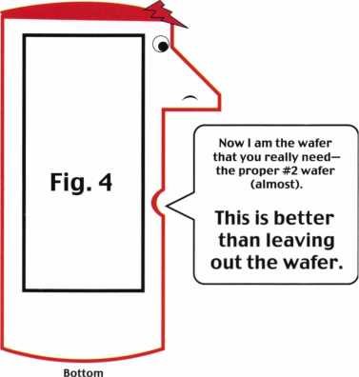

Keynotes • January 2002

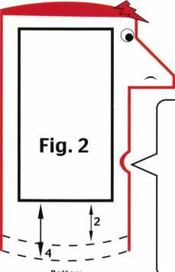

**RING of a KING**

Name Members

Recruited

Kwok-kei Leung 204

Toshihiro Asa no 113

Henry W. Raymond 100

Yuriko Yanai 69

Stewart J. Levine CML 66

Mary S. Ohmit CPL 66

Charles C. Robertson CML 65

Jack Hobin CPL 51

William B. Neff CML 48

Salvatore J. Dulcamara CML 40

Myeong-Rae Cho 38

Dana L. Barnum CML 35

Barry K. Leas CRL 35

David M. Lowell CML, CMST 34

C Allan Halverson 34

Danny W. Rudd CPL 31

Larry A. Warnick CML 31

Jeanne G. Lodge CML 30

Breck H. Camp CML 28

Dallas C. Brooks 28

William Lee 28

Lawrence F. Smith Jr, CML 27

James M. Watt CML, CPS 27

Jim Williams CRL 27

Anthony J. Ramunno CML, CPS 26 Marian M. Swann CRL 26

Jeffrey S. Nunberg CML, CMS 26 J Thomas Hood CML 26

John C. Elliott Jr, CML, CPS 25

Scott L. Henke CRL, CPS 25

James H. Glazier Sr, CML 25

Robert F. Carroll CPL 25

Robert H. Stafford CML 25

Robert D. DeWeese CML 24

Jerome L. Cohen CML 23

Peter K. Gauthier CPL, CPS 23

Elvis D. Hammerschmidt CPL 23

Man-Soo Seo 23

Diana R. Barnum CRL 22

Michael B. Groves 22

James J. Cawby CML, CPS 21

Philip A. Rovenolt CPL 21

Eugene R. Altobella Sr 21

John L. Shandy CML 19

Hans Mejlshede CML 19

John S. Dorsey CML 19

D Michael Lee Sr, CPL 19

Robert W. Duman Sr, CML 19

James E. Fowler Sr, CML 18

David C. Harris CML 1 8

William L. Young CML 18

Walter W. Lascar RL 17

Name Members

Recruited

Peter R. Hall 17

Thomas G. Vandersteen CML, CPS 17 William P. Grant CRL 17

Keizo Takahashi CRL 17

Evelyn V. Wersonick CML, CPS 16 Joseph P. Ferrero CML 16

Gary F. Teams CPL 16

Kenneth E. Kim CRL 16

Michael E. Jordan Jr, CML 16

Brian J. Reetz 16

Robert C. Rodocker CRL 15

William J. McElheney CML 15

Joseph W. Whitaker CPL 15

Jon B. Griswold CML 15

Michael D. Robinson CRL 15

Russell P. Fuller CRL 15

Daniel L. Landry Jr. 15

James L. Hancock CRL 15

James E. Gruber CRL 14

James T. Brickler CRL 14

Joseph C. Fuller CML, CMST 13

Leonard J. Passarello CPL 13

Frank D. Hartung CML 13

Rolando Bouza 13

Paul M. Souber 13

Donald H. Shiles RL 13

John A. Ilk CRL, CPS 13

Richard C. Sievers 13

Joe J. Lee CRL 13

Ernest W. Wright 1 2

John D. Cannon CML 12

John J. Greenan CML, CPS 12

Raymond C. Lusk CML 12

John F. Engel CRL 12

Eric F. Veal 12

Thomas J. Demont CML, AHC 11

Basil W. Shannon CPL 1 1

Calvin G. Harris CML 1 1

Herbert C. Dusenberry CML, CPS 1 1 Timothy K. Chow 11

Dale L. Knowles CPL 1 1

Alvin N. Minor 10

Gene Eldridge CPL 10

Ronald P. Riggins CML 10

Lester S. Brodsky 10

Larry L. Votaw CML 10

Thomas R. Smith CPL 10

William T. Straub CML 10

Richard T. Johnson CPL 10

Dale V. Crosby CPL 10

James V. Hawley CRL 10

Eugene R. Altobella Jr 10

James Bright 10



How can I join the President's Club?

You can earn a membership in this prestigious club by recruiting  
just 10 new members for ALOA.

*Any ALOA member may participate.

What do I get?

When you recruit 10 members, you receive a handsome  
blue blazer with a President's Club crest. For each add-  
itional five members you recruit, you receive a lapel pin  
with gold-filled numbers, indicating, your recruiting successes.

You also get the satisifaction of knowing that you are  
helping your association, helping your industry grow,  
and you are helping fellow locksmiths achieve success.

How do I get started?

Mail the form below to the ALOA office for a supply of  
applications (800) 532-ALOA or FAX (214) 827-1810.  
One President's Club credit is awarded for each new  
applicant. Credit is awarded only after the membership  
application is pproved. However, the credit will apply  
for the period in which the application is received.  
Failure to identify yourself as the sponsor on the application  
form at the time it is submitted to ALOA for processing will  
forfeit any credit.

Yes! I want to join the ALOA President's Club.

Please rush me applications so I can start earning credit toward membership in the club!

Company

Address

City

Zip

Mail this form to ALOA • 3003 Live Oak • Dallas, Texas 75204-6186

**During times of crisis, unity is key. Right now, when you join ALOA  
(or renew your membership), you will receive, free of charge,  
this patriotic decal for your shop or van, which serves as a  
special reminder to you and your customers that it takes  
a spirited effort to strengthen the ties that bind us.**

**IlLUII locksmiths**

Secure America

**Decal dimensions 8**y2" **x 5'/«'**

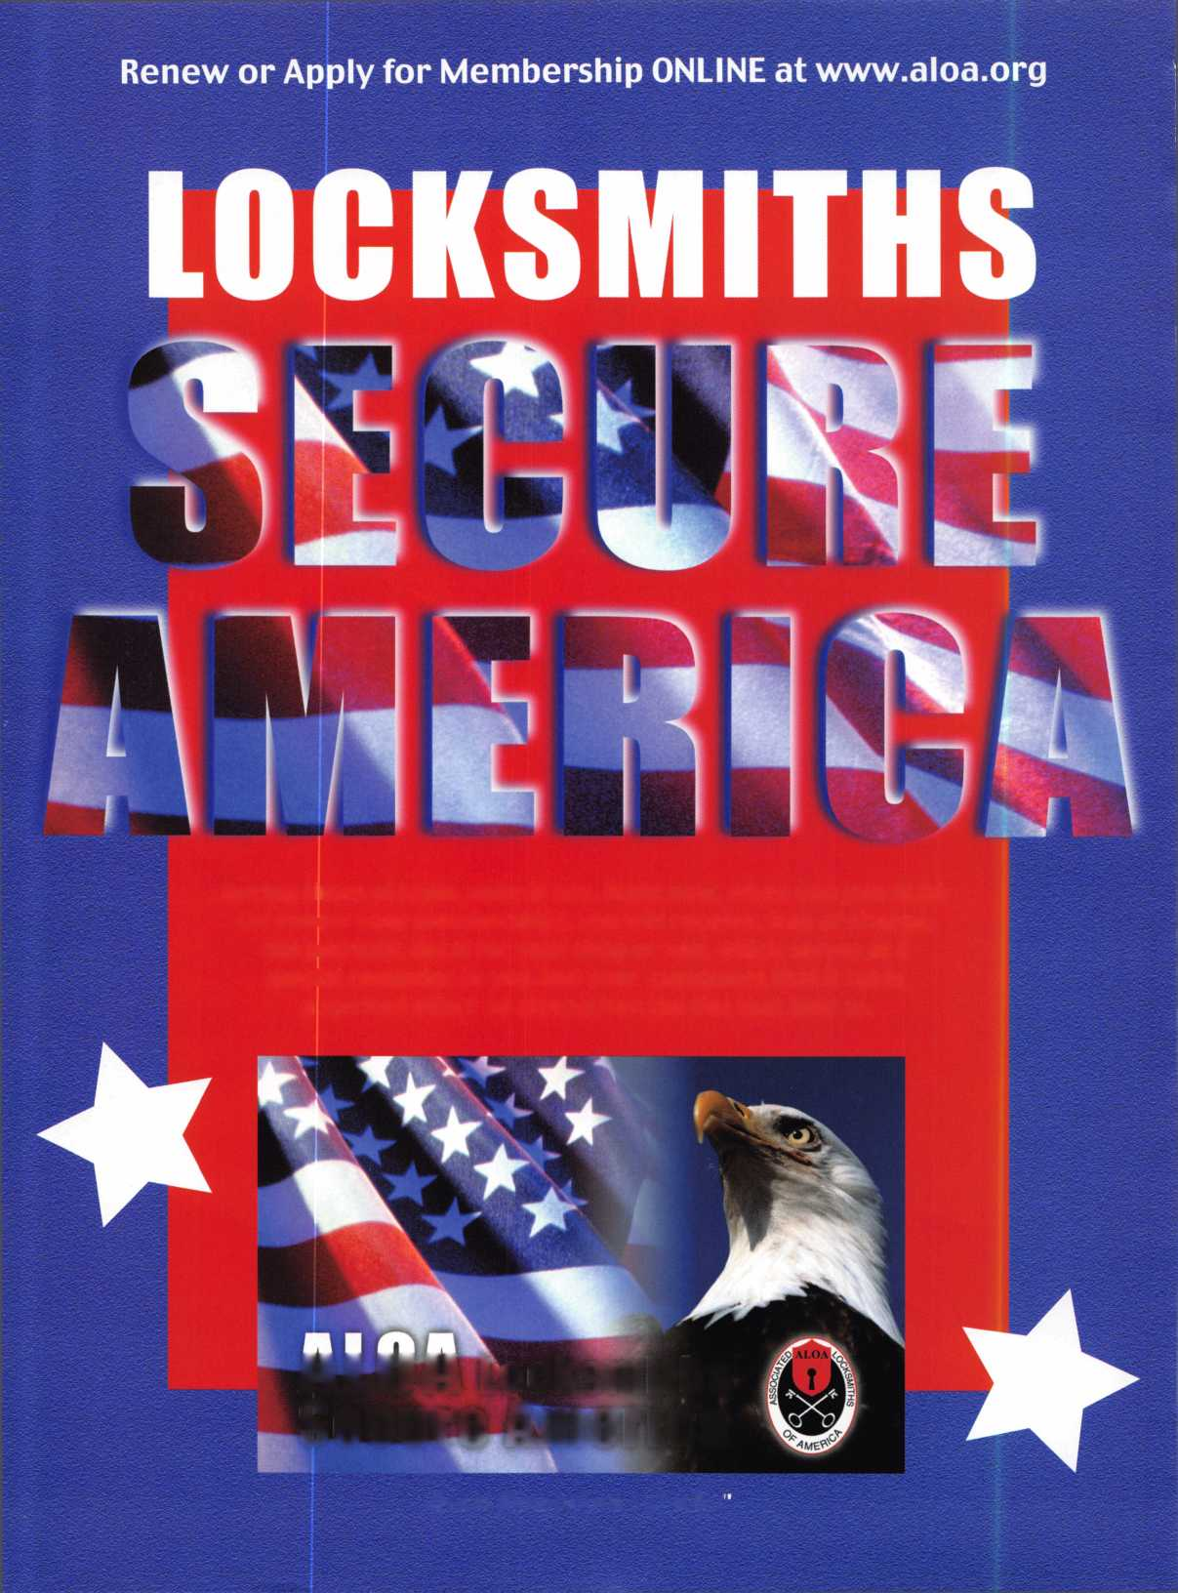

Flip Side of the Coin:

Whether Business is Booming or Busting,  
Keep in Mind These Simple Business Tips

By Claire L. Cohen, CML

Cutting Corners: Data Back-ups

As responsible business owners and man-  
agers, it is imperative to go through the  
necessary belt-tightening process whenever  
business economic conditions take a signif-  
icant downturn. Service calls slow down,  
big-ticket sales diminish, and our thoughts  
turn to ways to cut corners.

When times are slow, there may appear to

be some obvious expense areas to reduce. Initially, some may consider cut-  
ting various advertising, marketing, and computer-related expense. It may  
look as if the business has already poured a great deal money in computers,  
related supplies and software. Perhaps this might be one area to ignore for  
a while, or at least until the business could climb out of the economic hole.

It may be practical to postpone purchasing a new computer system, more  
laptops, or some new software. However, one budgetary area to keep is the  
computer backup/recovery line item. Perhaps when business takes a turn  
down, it may be time to increase the backup and recovery expense!

There are significant reasons why you should not tamper with data backup  
(either people expense or supply expense) during slow economic times.  
Information (data) is one of the most critical assets in your business. And  
lost data is irreplaceable! Hard disk crash, flood, fire, etc...we’ve all heard  
horror stories of businesses that have suffered data loss. If such a disaster  
does strike, we don’t want to be caught without a way to recover our data.

Some points to ponder...

Consider what may happen when a company fails to maintain quality  
backup procedures:

* Downsized staff have fewer people; the backup may be what doesn’t  
  get done.
* A long-term employee you had to let go after many years of service gets  
  disgruntled and erases some data on his/her last day at the office.

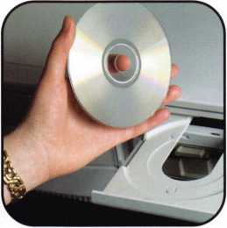

**Following a major  
data loss, could you  
or anyone on your  
staff put together:**

* **What are the company’s out­standing accounts receivable?**
* What is owed and what has been billed?
* **What are the outstanding accounts payable?**
* Who do you owe and how much do you owe?
* **Who are all of your customers?**
* Names, addresses, phone numbers, e-mail addresses
* Other pertinent information
* Past purchase information
* Key records
* **What information is needed for your vehicle(s)**
* Maintenance schedules
* Payment schedules
* Vehicle registration informa­tion
* **Who are all of your suppliers?**
* What do you purchase from each supplier?
* What is charged for items?
* What are your exact payroll numbers (assuming you do not have an outside service for this)?
* **What is in your inventory?**
* Part numbers
* Finishes
* Quantity to keep on hand

**This may be just a partial list of what  
could potentially be lost following a  
major data loss.**

Keynotes • January 2002

* You get rid of the offsite data storage location to save money and an employee takes your tapes home instead. Did you know that he had been thinking about starting a company to compete with you? He now has your valuable information.
* You defer buying new computer storage back-up devices and cancel maintenance contracts. Now the equipment fails more often.
* You buy fewer tapes in an attempt to save money.

You just reuse the archived tapes sooner, before the retention period is up and reuse them.

Morale suffers when you tighten the belt and people get careless and don’t do things by the book-things like backups.

Even special data processing rider on your insurance probably will only get you a check for equipment-it will not replace data lost. You can replace tools, computers, supplies and inventory, but data is irreplaceable and its loss could put you out of business.

The only viable insurance program for your data is to have a program in place for secure backups and recovery Off­site storage for instant retrieval in the event of a loss is a must! There are a very few things that can bring a company to its knees in just a few days. Data loss or destruction is certainly one of them.

Data is your most important strategic asset, regardless of the business or industry you are in. Don’t put the whole company at risk by cutting the backup budget just because business is a little slow. Data back-up is a suprisingly cost- effective way to preserve and protect the company when (or if) disaster strikes-and it might!

While we have focused on computer data back-up and recovery, don’t neglect paper backup too. Would you be able to replace paper records if they were destroyed? Most of us have sold safes to our customers and have emphasized the importance of protecting valuables. Data is our busi­ness “valuable”.

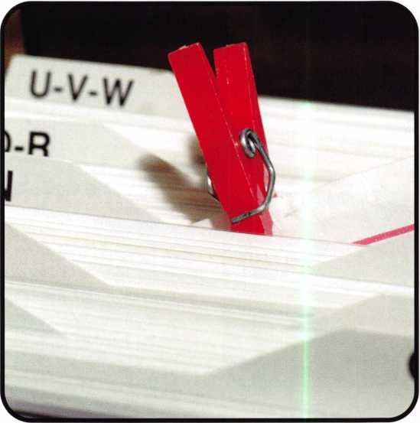

Don’t Forget to “Pack” your Customers

Business is booming, and you are out of space. The shop won’t accommodate that new piece of equipment, or a much-needed office area. Your display merchandise is out­growing its showroom area. You’d like to stock more parts, but there’s no space. You’ve lost your lease. The staff is increasing, but there’s no more room to sit. It’s time to relocate!

Time to celebrate. You have made the big decision, found a suitable new space and signed a lease. This is a very positive “move” for your business.

From the initial planning stages of trying to find the ideal location to the end, when the last box is out on the curb waiting for trash pickup, moving your business can be a challenge. Changing locations without losing customers can be an even greater challenge. With all the time and effort planning, packing, unpacking, and all the hassles in-between, good customers can get lost in the moving shuffle.

Information (data) is one of the most critical assets in your business. And lost data is irreplaceable. This is not an area to cut. Proper planning and preparation for backup and restoring your data can keep you business going!

When preparing and packing, don’t overlook the reason for your business existence, and perhaps the biggest consid­erations why you are moving: your customers. If your cus­tomers don’t know you are changing locations, they may not be able to find you when they need you. And perhaps

Keynotes • January 2002

Announcements can be inserted into sale flyers or billing statements. Don’t wait till you’ve moved

to make the announcement.

they will end up buying products or receiving security serv­ices from another company.

Moving a business is usually no fun. It’s a team effort of planning and implementation by the entire staff.

With a coordinated effort, your business can convey some excitement and enthusiasm about your new location to your customers. Before you start packing for your com­pany’s move, remember to announce your proposed reloca­tion to your clients.

Across the street, or across the city, it’s time to announce it to the world! Well in advance of the moving date, post signs on the counter:

* “We’re expanding”
* “To serve you better, we are moving to a new location”
* “Come visit us soon at our new, expanded store”

Announcements can be inserted into sale flyers or billing statements. Don’t wait till you’ve moved to make the announcement.

You have worked hard to find the right, new location.

Be proud of your new location. Take a picture of the new site and display it prominently - “our new home”. Place a picture of your new location in a conspicuous place where every customer and every employee will notice it.

Mention “the big move” in conversation with every cus­tomer. “By the way...don’t forget that the next time you need our security services, we’ll be at our new location...”

Send a press release to your local paper along with a picture of your new location. Publishers may write a small article, based on your press release, mentioning that your company has expanded services at a new location (without paying a penny for newspaper advertising).

Everyone in the company should be involved in letting your customers know that you will be changing location.

Enthusiastic about a new location, everyone in the compa­ny can be an ambassador announcing the “good news”.

An open house can be held for your customers. Invite customers to stop by and see your new space. “Stop by and pick up a free house key”. A few refreshments, and a tour of your new location, can prove to be a great marketing move. The tour could include some of the new products and services you provide with the additional space. A “free gift” or a prize drawing could be the incentive for some of your old customers to attend.

If your new location is not set up for a lot of traffic, ou may want to send your customers a “house-warming” gift, such as a keychain with your new address and /or phone number.

Don’t forget the telephone as a tool to announce your move. An “on-hold” message could be done announcing your new location with a short explanation of how much easier it will be for customers to do business with your company.

Plan ahead and have business cards, stationery, brochures and literature updated with your new address. Make sure to get rid of the old ones! Don’t forget to change phone book or long-term ads.

Look at the move as an opportunity to let your customers know where you’ve been and where you are going. **Your** customers want to know that the business they have chosen for their security needs is successful.

Moving from one location to another can offer many challenges. Proper advance preparations can surely pave the way for a smoother transition. When you are making the plans, don’t forget to “pack” that all-important com­modity: your customers ! Q

**33**

Keynotes • January 2002



2002 WILL BE A BUSY LEGISLATIVE YEAR FOR ALL LOCKSMITHS

"If you don't know where you're going, you could wind up some­place else" - Yogi Berra

Next year we ALL need to watch where we're going in state capitals across the U.S., or we could very well end up someplace else. Currently there are 8 bills from 7 states that were carried over from last year's legislative calendars which directly effect the professional security industry. Some allow for various tax credits for the installation of security systems, but most attempt to license our industry in some manner. Next year, careful monitoring and grassroots involvement will be key. That's where ALOA offers you all the resources you need right online at [www.aloa.org/news/legcom.cfm](http://www.aloa.org/news/legcom.cfm)!

YOUR'S FOR THE ASKING

Many of you already know that ALOA tracks legislation, and notifies members of pending bills that could effect their business. But many of you may not know that the resources that we use to keep you abreast of what's going on, is also AVAILABLE TO YOU TOO. The following are the legislative resources provided by ALOA:

CONTACT YOUR LEGISLATOR - we have an effective tool for bring­ing locksmiths and their state legislators closer together - right through the ALOA web site. Our service connects locksmiths to every member of the 50 state legislatures and provides up-o-date information about key issues. It creates personalized correspondence that can be printed out as a letter for faxing or mailing purposes. Grassroots lobbying at its finest!

STATENET - This is ALOA's legislative monitoring service. We can sign on to this everyday via the computer, and type in a few keywords like "alarm," "locksmith," "electrician," "electronic security," and immedi­ately bring up any bills or regulations that were introduced that effect our industry. Heard a rumor that a bill was introduced? Call us and find out for sure!

STATE YELLOW BOOK- This quarterly-updated resource has phone and fax numbers for every state representative, state senator, commit­tee chair, listing of committee members, and everyone in the execu­tive or judicial branch of state government. If you need a number, just call!

STATE LEGISLATIVE SOURCEBOOK- This handy little guide has every state agency listing, media service, news service, state lobbyist etc. Again, if you need a number, just call!

INTERNET SITES OF STATE LEGISLATORS- We've "bookmarked" on our website every state site, including every legislature's homepage. This allows us to look up text of bills, committee agendas, and even contact legislators via e-mail. A link to all bills is just a click away!

MODEL LAWS- Need a copy of any state law? We've got 'em! We've also written up summaries of many of the laws that effect lock­smiths or the access control industry. Even ALOA has a model law available online for your use.

INDUSTRY MEMBERSHIPS- To help keep the "pulse" of the security industry, ALOA is involved in many other organizations and coalitions including the National Council of State Legislators, The Electronic Systems Alliance, SIA Government Relations Committee, and the Consortium for Home & Building Systems Training. If you are interest­ed in being copied on any minutes, just let us know!

However, as we continue to expand our resources and become more competitive in the legislative arena, we need the monetary resources to match our successes. In your new dues billing, you will notice a donation of at least $24.95 to the Legislative Fund. Please add your donation onto your annual dues. This is only the minimum that we are asking, and encourage you to give more if you can. Those that con­tribute will be given a Legislative Action Network Member kit to use in their grass roots efforts. This kit includes:

* Legislative Action Network Update newsletter alerting you to impor­tant legislation in your state and around the country.
* Networking opportunities with ALOA members.
* Listing of your state representatives and senators for use in commu­nicating with your elected officials (hard copy and disk).
* Guide to lobbying in your state capital.
* LAN stationary and envelopes.
* LAN lapel pin designating you as a special ALOA LAN member.
* Recognition in Keynotes magazine.
* An invitation to the exclusive LAN reception at the annual ALOA convention.

Members who donate $100 or more become Legislative Action Network Council members, and enjoy the following extra benefits:

* A reserved place of distinction on the special LAN Council
* Discounts on ALOA bookstore items
* 10 % rebate on all ACE classes
* Complimentary Legislative Convention merchandise.

**34**

Keynotes • January 2002



**April 8-13**

John Ascuaga's Nugget Resort • Reno, Nevada

reno. nevada



2 V.^2

EXPERIENCED LOCKSMITH WANTED

Live, work, and enjoy Florida's east coast in beautiful Brevard, Co. Must be able to run after hour calls. Top salary and or commission. Call (888) 752-7233.

SECURITY TECHNICIAN NEEDED

Looking for experienced, motivated technician. We offer good income, 401 (k), medical plans. Fax us your resume at (781) 321-2422.

WANTED - EXPERIENCED TECHNICIANS

Lock into your future now! If you are an experienced, intelligent technician, and desire a secure future, come join our team.

We are a full service commercial / residential security service (locks,keys,safes,access control,cctv,all door related hardware,alarm systems) We offer: large sign on bonus, top wages, company vehicle, 401k, paid vacation and holidays, health benefits, new uniforms, cross training, and JOB SATISFACTION. We are looking for the best tech's who are ready to be treated and compensated as professionals. Contact: Bass Security Services, INC.

Phone: (216) 755-1200 ext. 128 Fax: (216) 755-1220 Toll free: (800) 523-1422 e-mail: [rmesnick@bass-security.com](mailto:rmesnick@bass-security.com)

WANTED - SALES SUPERSTAR

Here we grow again! Bass Security Services, Inc. is looking for the best of the best. If you are an experienced, motivated, and no-nonsense sales professional with an extensive background in the security industry, we want YOU! All candidates must have a minimum of 5 years in the locksmith/security field, with a back­ground in sales and customer service. We offer: Top wages with excellent incentives , 401k, paid vacation and holidays, health benefits, and continued industry education. Re-location assis­tance may be provided. Contact: Bass Security Services, Inc.

free: (800) 523-1422 e-mail: [rmesnick@bass-security.com](mailto:rmesnick@bass-security.com)

WANTED

Experienced Service Technician sought for established company in central Illinois. Must be neat in appearance with good work habits. Good driving record a must. Our company offers a good salary with an excellent benefits package. Many extras. Send resume or contact: Denny, Dave and Harry Locksmiths,

Inc. 1 16 E. University Ave. • Champaign, IL 61820 Phone: (217) 352-5034 • Fax: (217) 352-3505

LOCKSMITH WANTED

Busy shop in Woburn, MA, has immediate opening for a self- motivated, reliable locksmith. Large customer databases for automotive, AAA, commercial and residential accounts. Applicant with own van and tools is guaranteed 50 percent commission. If no van or tools, we can supply. A great opportu­nity for the right individual. All inquiries are kept strictly confi­dential. Send resume to: Locks and Keys Inc. • P.O. Box 222 Woburn, MA 01 801 • e-mail: [jobs@locks-keys.com](mailto:jobs@locks-keys.com) Phone: (781) 933-9999.

EXPERIENCED LOCKSMITH WANTED

Do you love the trade of Locksmithing? Are you hard working and self motivated? If you are, we are the company for you.

A growing locksmith company in California is looking for techs that work with automotive, commerical and residential. Looking for techs that has a min. of 2 yrs. of exp. We offer full benefit package and payed vacation. Trucks and tools are provided. Clean driving record. High salary is payed to top technicians. Take pride in where you work and come aboard on a winning team. Locksmith Central • 15934 Hesperian Blvd. Suite 264 • San Lorenzo, Ca 94580 Voice: 1.888.81.LOCKS



Classified Advertising Policy

Classified advertising space is provided free of charge to ALOA members, and fora fee of $.60 per word', $15 minimum for non-members. Classified ads may be used to advertise  
used merchandise and overstocked items for sale, "wanted to buy" items, business opportunities, employment opportunities/positions wanted and the like. Members or non-members wishing  
to advertise services or new merchandise for sale may purchase a "Commercial Classified Ad," for a fee of $1.30 per word, with a minimum of $40. Each ad will run for two issues. For blind  
boxes there is a $5 charge to members and non-members. All ads must be submitted in writing to the ALOA office by the fifteenth of the month, two months prior to issue date. Send to  
Keynotes Classifieds, 3003 Live Oak St., Dallas TX 75204-6186. ALOA reserves the right to refuse any classified advertisement that it deems inappropriate according to the stated purpose

of the classified advertising section.

**36**

Keynotes • January 2002

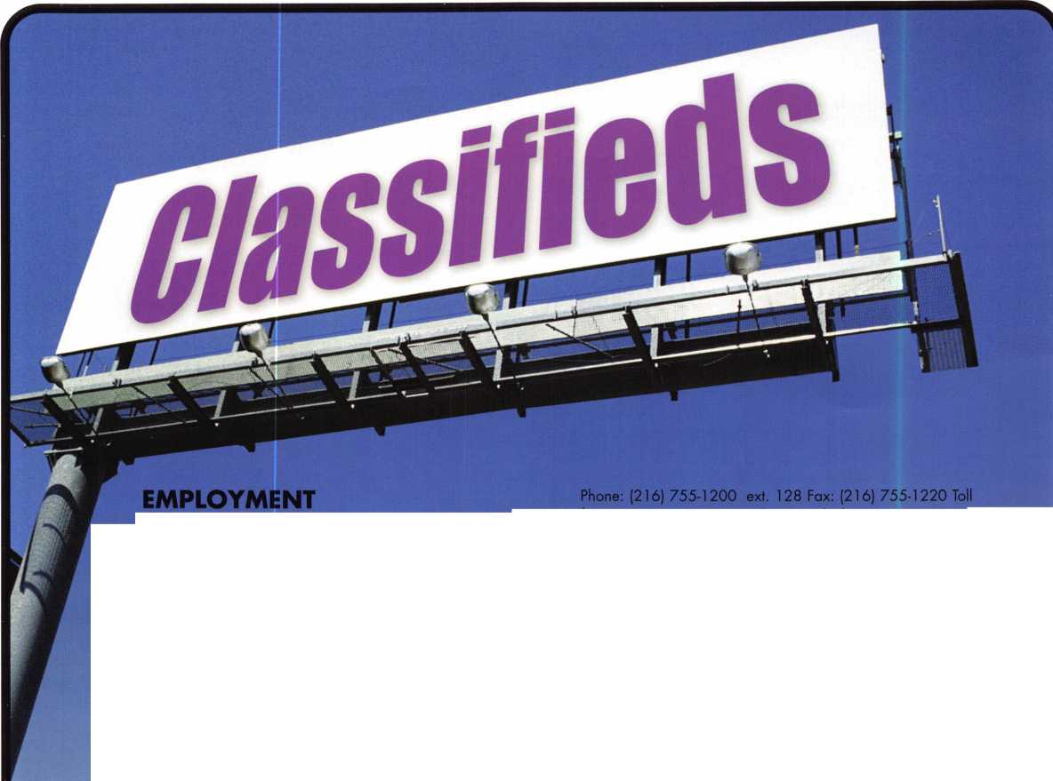

LOCKMASTERS INC.

of Nicholasville, KY, a leader in automotive and locksmith tools is looking a for self-motivated person to fill our growing and fast paced automotive and locksmith tool inside sales staff. Must be people oriented, a self starter, have overall understanding of locksmith market, and be willing to relocate to Nicholasville/Lexington Kentucky. Background in automotive and general locksmithing a plus. Send resume to Lockmasters Inc., 5085 Danville Rd., Nicholasville, KY 40356.

WANTED TO BUY

We are in need of a discontinued unit lock made by Corbin Lock Inc.

The old series number was 966-35lx C26D. If you can assist us in locating, new or used locks it would be greatly appreciated.

Craig Smith, Facilities Management 2500 University Drive N.W. ST 068 Calgary, Alberta T2N 1 N4 Canada Business: (403) 220-3680 Mobile: (403) 512-9536 • Fax: (403) 210-8142 e-mail: [csmi@ucalgary.ca](mailto:csmi@ucalgary.ca)

WORK WANTED

SECURITY PRO FOR HIRE

CML, CPS seeks a challenging and personally rewarding position as a Locksmith, at the supervisor or management level. Would prefer institution or college in the Midwest or central United States, however all locations would be considered. 30+ years in the field and well versed in all aspects of sales, training and management. Please respond to the editor at ALOA,

(800) 532-2562, ext. 19.

BUSINESS FOR SALE

ESTABLISHED LOCKSMITH AND SECURITY BUSINESS FOR SALE Are you looking for a great business opportunity, sinchine, clean air and a great community for raising a family? We've got it! Building, businesses and rental property are all included. Business is located in south central Colorado in a growing community. Call PORTER REALTY for more information! (719) 589-5899.

FOR SALE

Tampa Florida's foremost mobile locksmith service. Established 1982.

Sale includes merchandise, assets, 1996 service van and customer list. Contact Richard at [Towerkey3@aol.com](mailto:Towerkey3@aol.com), or call (813) 985-2028.

ESTABLISHED LOCKSMITH AND SECURITY BUSINESS FOR SALE Are you looking for a great business opportunity, sunshine, clean air and a great community for raising a family? We've got it! Building, businesses and rental property are all included. Business is located in south central Colorado in a growing community. Call Porter Realty for more information, (719) 589-5899.

BUSINESS FOR SALE

Well established lock and safe company (19 years) with many long-time account customers. Three fully equipped vans, two pick-ups, shop equipment, etc. Located in super-fast growing area in Maryland.

Gross $500K with loads of growth potential. Serious inquiries call Dave @ (301) 748-1885.

BUSINESS FOR SALE

Located in Hayward, California. Company been around for 6 years. Have a large number of commerical Accounts. In this territory we have a contract with AAA. Heavy commerical and automotive work done. Looking for a person that well trained in Locksmithing to take over operations. Meaning Commerical, Automotive, Residential. Gross Sales per year are $400,000+ Call For Details. Ask for Robert: (888) 81-LOCKS

WANTED TO BUY/SELL

FOR SALE

Ilco/Orion KD56 C/E High Security Winder Key Machine. Also cuts KESO keys. $600 plus shipping and handling. Call John at (203) 397-3093, or e-mail to [amitylock@snet.net](mailto:amitylock@snet.net).

FOR SALE

Used Woodword Stairclimber - great condition - $1500. Contact Wayne Parker at A-l Key and Safe, Inc. (727) 525-5513.

Locksmith Training

Sponsored by Fox Valley Technical College • 1825 N. Bluemound Dr. • Appleton, Wl 54912-2277

6-Day Program • Career Change in One Week • March 18-23, 2002

This is a basic locksmithing training course sponsored by FVTC’s Security and Crime Prevention  
Department and conducted by ALOA ACE instructors. Designed for the locksmith shop owner  
who would like to provide entry-level training for new apprentice locksmiths as well as those who

would like to receive professional training that will enable employment with a professional locksmith. The course will allow the student  
to gain enough knowledge to make them a starting apprentice in an existing shop. Job placement locations will be made available at the  
time of the class.

To maintain quality the course enrollment will be capped at 12 students. Enroll early!

Curriculum includes:

Key Blank Identification and Duplication Key Codes and Code Equipment Basic Master Keying

Lockset Servicing, Functions, Finishes

Life Safety Codes

Lock Pick Opening Techniques

Pin and Disc Cylinder Servicing Key Impressioning

Lock By-Pass Techniques Exit Hardware

Door Closers

Lockset Installation

Cabinet, Furniture, Mailbox Locks

All tools and equipment will be made available for use during training. Class Hours: 8:30 am to 5:00 pm every day Class Attire: Shop clothes Course Tuition: $995.00

Course Enrollment: See Linda Buck in the Criminal Justice Center

or call 920-735-2406

Note: Enrollment deadline is Friday, February 15, 2002

Keynotes • January 2002

**3**



A & B Safe Corporation

Phone: 800-253-1267 Fax: 856-863-1208 [www.a-bsafecorp.com](http://www.a-bsafecorp.com)

ADI Inc

Phone:516-692-1000 Fax: 516-692-3457

Abloy Door Security

Phone:514-335-9500 Fax: 514-335-0430 [www.abloy.com](http://www.abloy.com)

Accredited Lock Supply Co

Phone: 201-865-5015 Fax: 201-865-0030 [www.acclock.com](http://www.acclock.com)

Ace Lock & Security Supply

Phone: 908-688-7666 Fax: 908-688-2442 [www.acelock.com](http://www.acelock.com)

Action Hardware Inc

Phone: 800-662-6695 Fax: 800-930-2329

Action Hardware

Phone: 800-662-6695 Fax: 800-930-2329

Adams Rite Mfg Company

Phone: 800-872-3267 Fax: 800-232-7329 [www.adamsrite.com](http://www.adamsrite.com)

Adesco Safe Mfg. Company

Phone: 800-821-6803 Fax: 562-408-6427 [www.adesco.com](http://www.adesco.com)

Adrian Steel Company

Phone: 800-677-2726 Fax: 517-265-5834 [www.adriansteel.com](http://www.adriansteel.com)

Alarm Lock Systems Inc.

Phone: 800-252-5625 Fax: 516-789-3383 [www.alarmlock.com](http://www.alarmlock.com)

Allstate Insurance Company

Phone: 847-402-8196 Fax: 847-326-7509 [www.allstate.com](http://www.allstate.com)

American Lock Company

Phone: 708-534-2000 Fax: 708-534-0531

American Security Products

Phone: 909-685-9680X1083 Fax: 909-685-9685 [www.amsecusa.com](http://www.amsecusa.com)

Andrews Wholesale Lock Supply

Phone: 717-272-7422 Fax: 717-274-8659

BWD Automotive

Phone: 334-872-6524 Fax: 334-874-6011 [www.bwdautomotive.com](http://www.bwdautomotive.com)

Baldwin Hardware

Phone: 610-796-4012 Fax: 610-796-4493

Boyle & Chase Inc

Phone: 800-325-2530 Fax: 800-205-3500 [www.boyleandchase.com](http://www.boyleandchase.com)

Buddy Products

Phone: 800-886-8688 Fax: 312-733-8356

COMPX Security Products

Phone: 864-297-6655 Fax: 864-297-9987 [www.nclnet.com](http://www.nclnet.com)

Clark Security Products

Phone: 800-854-2088 Fax: 619-974-5284

Cook's Building Specialties

Phone: 505-883-5701 Fax: 505-883-5704

Curtis Industries,

A Barnes Distributor

Phone: 800-555-5397 Fax: 800-867-6020 [www.curtisindustries.com](http://www.curtisindustries.com)

DETEX Corporation

Phone: 800-729-3839 Fax: 830-620-6711

DORMA Architectural Hardware

Phone: 717-336-3881 Fax: 717-336-3500 [www.dorma-usa.com](http://www.dorma-usa.com)

DSC Group Of Companies

Phone: 905-760-3000 Fax: 905-760-3040

Dire's Lock & Key Company

Phone: 303-294-0176 Fax: 303-294-0198

Direct Security Supply, Inc.

Phone800-252-5757 Fax800-452-8600

Don-Jo Manufacturing, Inc.

Phone: 978-422-3213 Fax: 978-422-3467 [www.don-jo.com](http://www.don-jo.com)

Door Controls International

Phone: 800-742-3634 Fax: 800-742-0410 [www.doorcontrols.com](http://www.doorcontrols.com)

Doyle Security Products

Phone: 800-333-6953 Fax: 612-521-0166 [www.doylesecurity.com](http://www.doylesecurity.com)

Dugmore and Duncan, Inc.

Phone: 888-384-6673 Fax: 888-329-3846

E. L. Reinhardt Co., Inc.

Phone: 800-328-1311 Fax: 612-481-0166 [www.elreinhardt.com](http://www.elreinhardt.com)

ESP Lock Products Inc.

Phone: 978-537-6121 Fax: 978-534-9109

Emergency Road Service Inc

Phone: 888-839-5386 Fax: 678-277-8105

Ewert Wholesale Hardware

Phone: 800-451-0200 Fax: 708-597-0881

Fairway Supply, Inc.

Phone: 214-350-0021 Fax: 214-352-4299 [www.fairwaysupply.com](http://www.fairwaysupply.com)

Foley-Belsaw Company

Phone: 800-821-3452 Fax: 816-483-5010 [www.belsaw.com](http://www.belsaw.com)

Fried Brothers Inc.

Phone: 800-523-2924 Fax: 215-592-1255

H L Flake Co

Phone: 800-231-4105

H.S. & S. Wholesale Distrib.

Phone: 313-342-6777 Fax: 313-342-7580

HES, Inc

Phone: 623-582-4626 Fax: 623-582-4641 [www.hesinnovations.com](http://www.hesinnovations.com)

HPC, Inc.

Phone: 847-671-6280 Fax: 847-671-6343 [www.hpcworld.com](http://www.hpcworld.com)

Hans Johnsen Company

Phone: 214-879-1550 Fax: 214-879-1530

Hardware Agencies, Ltd.

Phone: 416-462-1921

Hongtai Lock Co Ltd

Phone: 137-238-1414 Fax: 208-793-3856

Howard Keys

Phone: 704-509-4944 Fax: 704-509-6248 www. h owa rd keys .com

IDN Incorporated

Phone: 817-421-5470 Fax: 817-421-5468

INTELLIKEY Corp.

Phone: 800-226-0703 Fax: 321-724-081 1 [www.intellikey.com](http://www.intellikey.com)

llco Unican

Phone: 252-446-3321 Fax: 252-446-4702 [www.kaba-ilco.com](http://www.kaba-ilco.com)

Intermountain Lock & Supply

Phone: 800-453-5386 Fax: 801-485-7205 [www.intermountainlock.com](http://www.intermountainlock.com)

Jensen Tools Inc

Phone: 602-453-3169 Fax: 602-438-1690

Jet Hardware Mfg., Co.

Phone: 718-257-9600 Fax: 718-257-0973

Jo Van Distributors

Phone: 416-752-7249 Fax: 416-752-3845

KABA High Security Locks

Phone: 860-621-3601 Fax: 860-621-9727 [www.kabausa.com](http://www.kabausa.com)

KEY-BAK/West Coast Chain Mfg

Phone: 909-923-7800 Fax: 909-923-0024 www. key ba k. co m

Keynotes



Knaack Manufacturing Co.

Phone: 800456-7865 Fax: 815-459-9097 [www.weatherguard.com](http://www.weatherguard.com)

LAB Security

Phone: 800-243-8242 Fax: 860-583-7838

LCN Closers/Div of Ingersoll

Phone: 815-875-3311 Fax: 815-879-1497 [www.lcnclosers.com](http://www.lcnclosers.com)

La Gard Inc.

Phone: 310-325-5670 Fax: 310-325-5615 [www.lagard.com](http://www.lagard.com)

Lockmasters, Inc.

Phone: 859-885-6041 Fax: 859-885-7093 [www.lockmasters.com](http://www.lockmasters.com)

Locks Company

Phone: 800-288-0801 Fax: 305-949-3619

Locksmith Ledger International

Phone: 770-886-0800 Fax: 770-889-7703 lledger.com

Lucky Line Products, Inc.

Phone: 858-549-6699 Fax: 858-549-3241

M. Zion Company

Phone: 212-349-8677 Fax: 212-964-0495

M.A.G. Security

Phone: 714-891-5100 Fax: 714-892-6845 [www.magsecurity.com](http://www.magsecurity.com)

MARKS, U.S.A.

Phone: 516-225-5400 Fax: 516-225-6136 [www.marksusa.com](http://www.marksusa.com)

Marray Enterprises

Phone: 408-970-0213 Fax: 408-970-8767

MCS Communication Systems

Phone: 514-444-2040 Fax: 514-444-2029 [www.mcscommunication.com](http://www.mcscommunication.com)

MUL-T-LOCK USA, Inc

Phone: 800-562-3511 Fax: 973-778-4007 [www.mul-t-lock.com](http://www.mul-t-lock.com)

Massglass & Door Service

Phone: 888-742-8837 Fax: 818-991-5742 [www.massglass.com](http://www.massglass.com)

Master Lock Company

Phone: 414-444-2800 Fax: 414-444-0322 [www.masterlock.com](http://www.masterlock.com)

McDonald Dash Locksmith Supp

Phone: 800-238-7541 Fax: 901-366-0005 [www.mcdonalddash.com](http://www.mcdonalddash.com)

McManus Locksmith Supply, Inc.

Phone: 704-333-9112 Fax: 704-332-8664

Medeco Security Locks

Phone: 540-380-5000 Fax: 540-380-5010 [www.medeco.com](http://www.medeco.com)

Meilink Safe Company

Phone: 800-634-5465 Fax: 800-896-6606

[www.fireking.com/products_Meilink/mk](http://www.fireking.com/products_Meilink/mk)

Monaco Lock Co.

Phone: 800-526-6094 Fax: 800-845-5625 [www.monacolock.com](http://www.monacolock.com)

Mountain Mold and Dye Inc.

Phone: 865-428-3611 Fax: 865-453-4136

Omaha Wholesale Hardware

Phone: 800-238-4566 Fax: 402-444-1664 [www.omahawh.com](http://www.omahawh.com)

ROFU International Corp

Phone: 800-255-7638 Fax: 253-922-1728 [www.rofu.com](http://www.rofu.com)

Rutherford Controls Int'l Co

Phone: 757-427-1230 Fax: 757-427-9549 [www.rutherfordcontrols.com](http://www.rutherfordcontrols.com)

ST R ATT EC Security Corp.

Phone:414-247-3333 Fax: 414-247-3329

Sargent & Greenleaf, Inc.

Phone: 606-885-9411 Fax: 606-885-3063 [www.sglocks.com](http://www.sglocks.com)

Sargent Manufacturing Co

Phone: 203-562-2151 Fax: 203-776-5992

Schlage Lock Co

Phone: 719-264-5300 Fax: 719-264-5382 [www.schlagelock.com](http://www.schlagelock.com)

Schwab Corp

Phone: 765-447-9470 Fax: 765-447-8278 [www.schwabcorp.com](http://www.schwabcorp.com)

SecureRite.Com

Phone: 800-241-3930 Fax: 858-974-5269 [www.SecureRite.Corn](http://www.SecureRite.Corn)

Securitron Magnalock Corp.

Phone: 775-355-5626 Fax: 775-355-5636 [www.securitron.com](http://www.securitron.com)

Security Distributors Inc

Phone: 800-333-6953 Fax: 612-524-0166

Security Door Controls

Phone: 805-494-0622 Fax: 805-494-8861 [www.sdcsecurity.com](http://www.sdcsecurity.com)

Security Solutions

Phone: 405-376-1600 Fax: 405-376-6870

Sentry Group

Phone: 716-381-4900 Fax: 716-381-8559 [www.sentrysafe.com](http://www.sentrysafe.com)

Sentry Security Fasteners

Phone: 309-693-2800 Fax: 800-693-2872

Somerset Security Products

Phone: 800-881-5206 Fax: 800-206-9949

Southern Lock and Supply Co.

Phone: 727-541-5536 Fax: 813-544-8278 southernlock.com

Stone & Berg Wholesale

Phone: 800-225-7405 Fax: 800-535-5625

Sully Tools Inc

Phone: 703-689-3416 Fax: 703-787-0869 [www.sullytools.com](http://www.sullytools.com)

SunSafes Manufacturing Co.

Phone: 823-194-59300 Fax: 823-194-59400 [www.eaglesafes.com](http://www.eaglesafes.com)

Taylor Security & Lock

Phone: 301-948-7670 Fax: 301-948-1029 [www.taylorsecurity.com](http://www.taylorsecurity.com)

Taymor Industries, Inc.

Phone: 800-388-9887 Fax: 800-288-8133

The Locksmith Store Inc.

Phone: 847-364-5111

Fax847-364-5125

[www.locksmithstore.com](http://www.locksmithstore.com)

The National Locksmith

Phone: 630-837-2044 Fax: 630-837-1210 [www.thenationallocksmith.com](http://www.thenationallocksmith.com)

Timemaster Inc

Phone: 888-798-8465 Fax: 800-798-8463

Top Notch Distributors, Inc.

Phone: 570-253-5625 Fax: 570-253-6765 [www.4topnotch.com](http://www.4topnotch.com)

Trine Access Technology

Phone: 718-829-2332 Fax: 718-829-6405 [www.trineonline.com](http://www.trineonline.com)

U.S. Lock Corp.

Phone: 800-925-5000 Fax: 800-338-5625 [www.uslock.com](http://www.uslock.com)

Videx Inc

Phone: 541-758-0521 Fax: 541-752-5285

W-Lok Corporation

Phone: 616-355-4015 Fax: 616-355-4295 [www.wlokcorp.com](http://www.wlokcorp.com)

Webster Safe & Lock Co., Inc

Phone: 901-332-2911 Fax: 901-332-2878 webstersinc.com

Yale Security Group, Inc.

Phone: 800-438-1951 Fax: 800-338-0965

Et

Keynotes • January 2002

**3**

**back page**

About the Authors

Lee Griggs has been a big player in the security industry since the mid-60s, starting and selling companies, participating in organizations at the local, state and national level and working to increase the educational standards of the pro­fession. He is currently teaching seminars to insurance companies, law enforcement and locksmith groups on investigative locksmithing, forensic locksmithing, auto theft and questioned entry. Lee teaches seminars on marketing and business planning for the small businessman. Seminars scheduled for 2001 include Marketing, Access Control, Business Planning and Forensics. He also provides consulting serv­ices for businesses and institutions regarding access control systems, master key systems, key control, and loss prevention. Recently designed and implemented a major master key system, including high security keying, for a large medical complex in South Carolina.

Greg Perry, CML, CPS, has been in the lock­smith industry for 18 years. He’s spent half of that time as a field technician for Security Engineering in Ridgecrest, Calif. Greg is also a past president of the Desert Counties Chapter of the California Locksmiths Association.

Claire Cohen, CML the second woman to become a CML, has been in locksmithing since 1977 and has been writing articles for Keynotes since 1987. She is also a contributing editor for Keynotes, and was just named the 2001 Keynotes Author of the Year - again, the second woman to achieve that honor.

Ronald "Red" Howell, CRL has been in the lock­smithing industry since 1959. In 1980 Red started his own business specializing in automo­tive locks.. Red began teaching in 1982 for ALOA . Red was the first vice chairperson for the San Diego Chapter of ALOA (August 1986). During the years he has held about every elected office for the San Diego Chapter of the California Locksmiths Association (CLA). Currently , he is the San Diego Chapter President for CLA, chair­man of the San Diego Chapter of ALOA and active member of the San Diego Forensic Consultants Association. He also is teaching ACE ALOA convention classes and is currently re-writ- ing a manual on foreign automotive lock repair from the 1950's to 1970'S

Merritt Perkins, RL, has been a developing member of the locksmith and eletronics indus­tries for many years. He owns and operates Merritt L. Perkins Labs in Three Rivers, Ml.

a c fief away fromyour

security door hardware needs:

[www.jlmwholesale.com](http://www.jlmwholesale.com)

OVehsite features:

Detailed product information.  
Search capabilities on each page.  
Check box to display only in stock items.  
New quick links. Extremely user friendly.  
Downloadable interactive product catalog.

K,nanorre, rvo i-auu-foo-ouou*

[www.jlmwholesafe.com](http://www.jlmwholesafe.com)

(jriAvr w/ntrtc

Qet 'free 'Treiyfit!

|  |  |
| --- | --- |
| **r** |  |
| **Ad Index** |  |
| Hickock, Inc | l |
| JLM Wolesale | Back page |
| Yale | ... Back Cover |
| **L.** | **J** |

Keynotes • January 2002



July 22-28, 2002 • Donald E. Stephens Convention Center • Hyatt Regency O'Hare

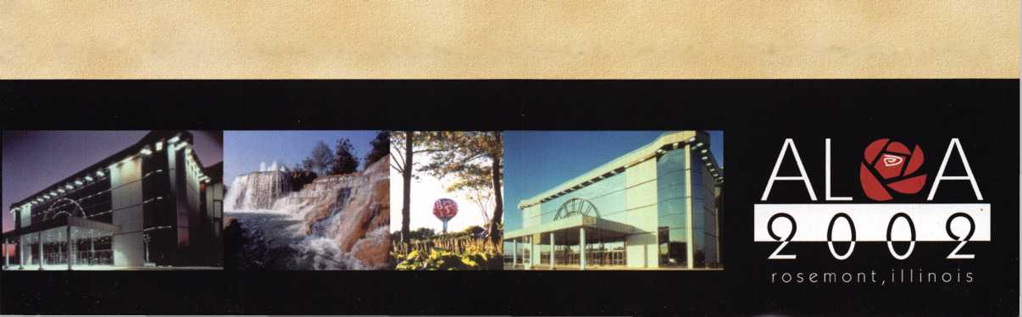

Yale® and Yale Security Inc.® are registered trademarks of Yale Security Inc. SecureX™ is a trademark of Yale Security Inc.

r

Sure, old Spike here will do the job. But you're going to have to feed him and walk him. SecureX,™our new patent pending controlled exit device with delayed egress, will stop anyone in their tracks without taking a bite out of their backside. It's the kind of product you've come to expect from Yale, one of the most respected names in the industry. So you have a decision to make. Contact us at 888-828-8349, or visit our website at [www.yalelocks.com](http://www.yalelocks.com) to find out more. Or go buy 50 lbs. of dry dog food.

Delayed Egress Exit Device

